Prasar Srivastava  
22BCE10841  
AWS CLOUD Architect CSE3016  
Submitted To-Dr. Munsifa Firdaus Khan

STEP1: LOGIN AS A ROOT USER AND SEARCH FOR VPC IN THE CONSOLE

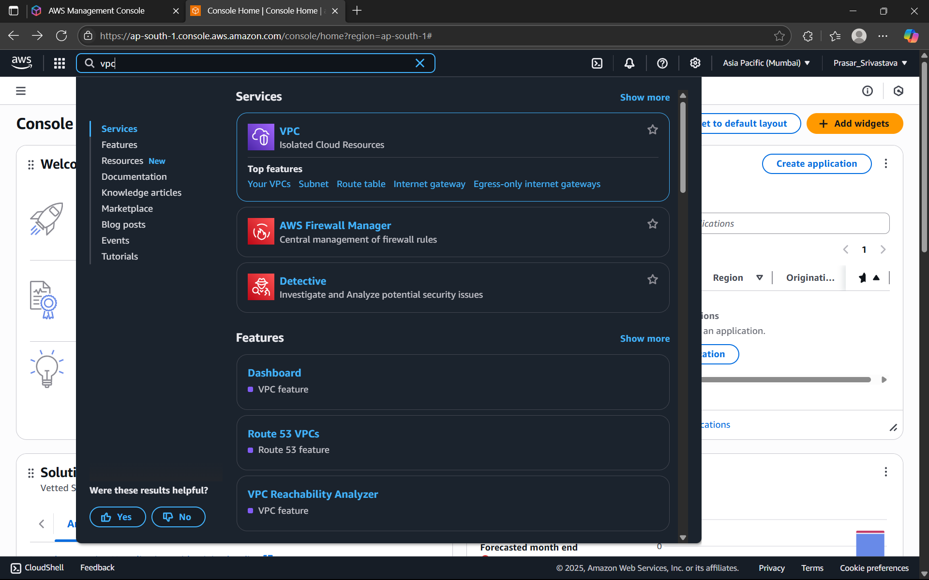

STEP2: CLICK ON CREATE VPC

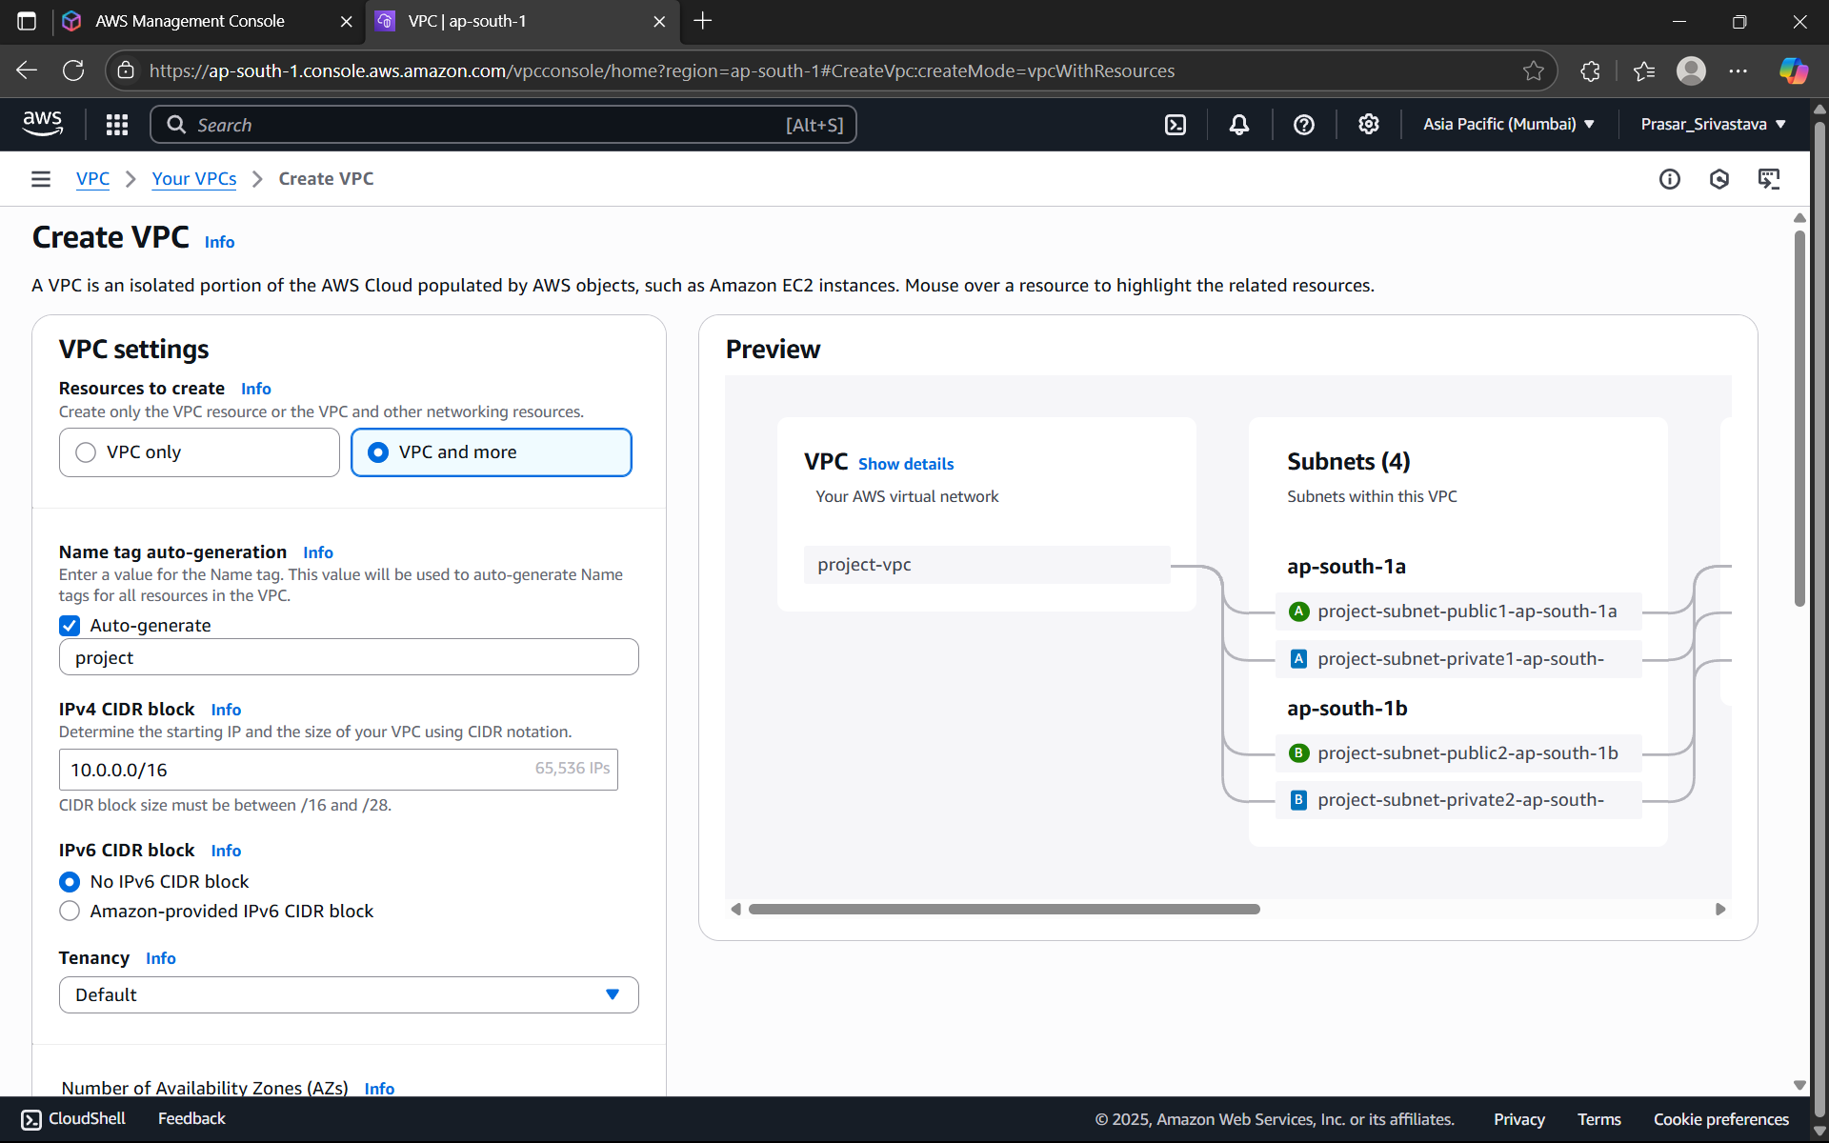

STEP3: SELECT VPC ONLY> TYPE THE VPC NAME> IPv4CIDR-11.0.0.0/16

NOTE: In AWS a VPC spans a specific IP address range using CIDR (Classless Inter-Domain

Routing) blocks. The CIDR block defines the range of IP addresses that can be assigned to

resources within the VPC

For better understanding of the CIDR range, Search CIDR Range Calculator in google and

enter the range. Here its showing 65536 IP range, i.e. these are the maximum number of IP

addresses which is accessible by the VPC. If we increase from /16 to /32, it will decrease

the number of IP address and if we decrease it to /8, it will increase the number of IP

addresses. (/16 means first 16bits are locked)

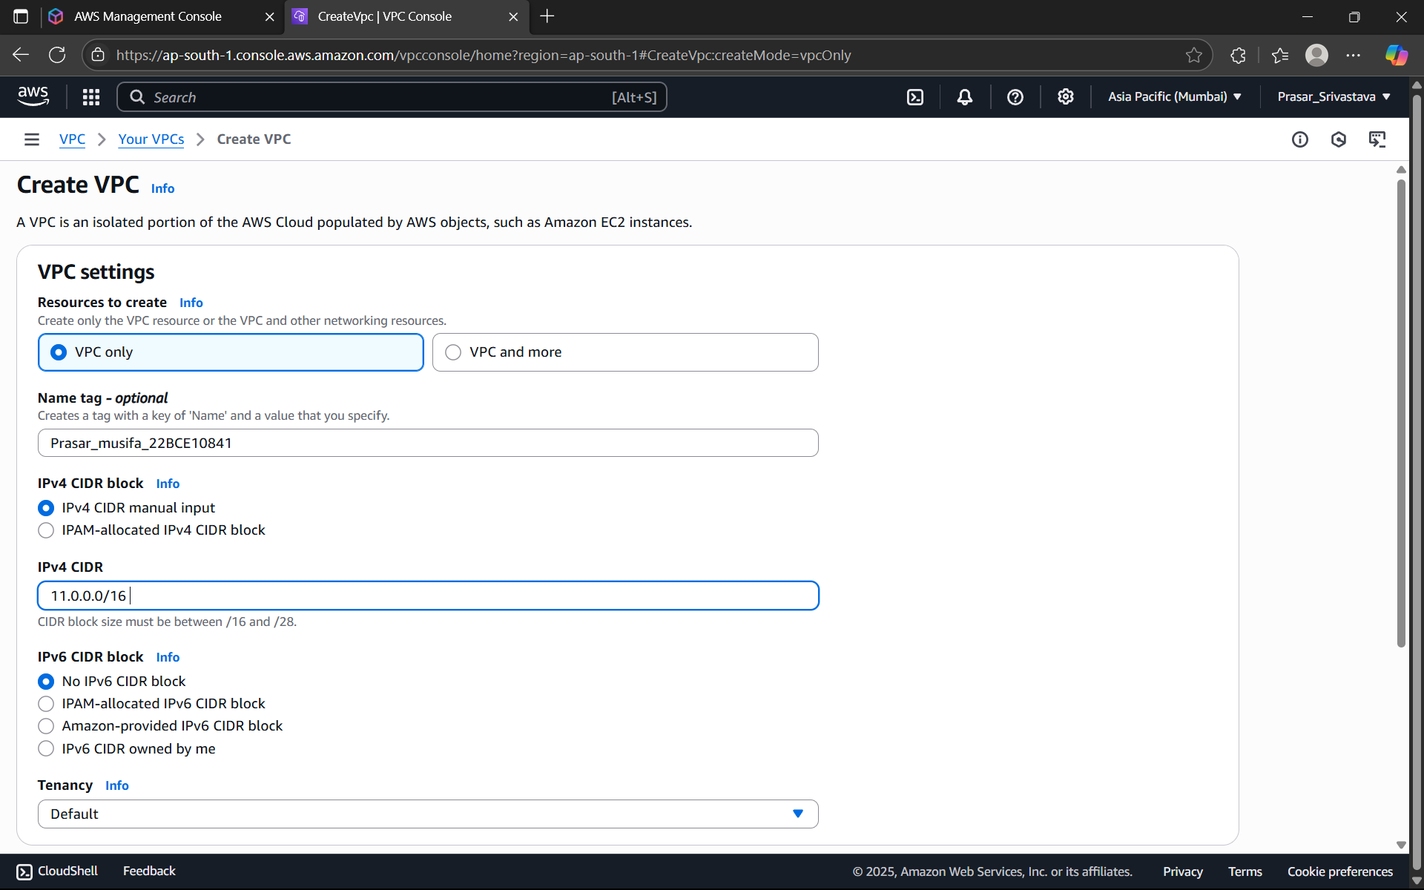

STEP4: CLICK ON CREATE VPC

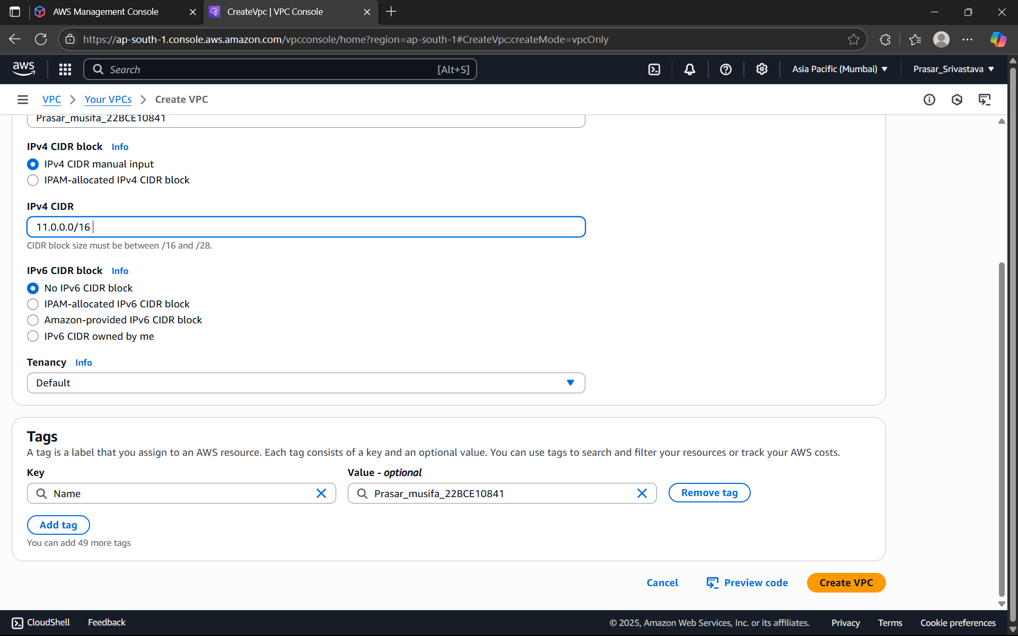

STEP5: VPC CREATED

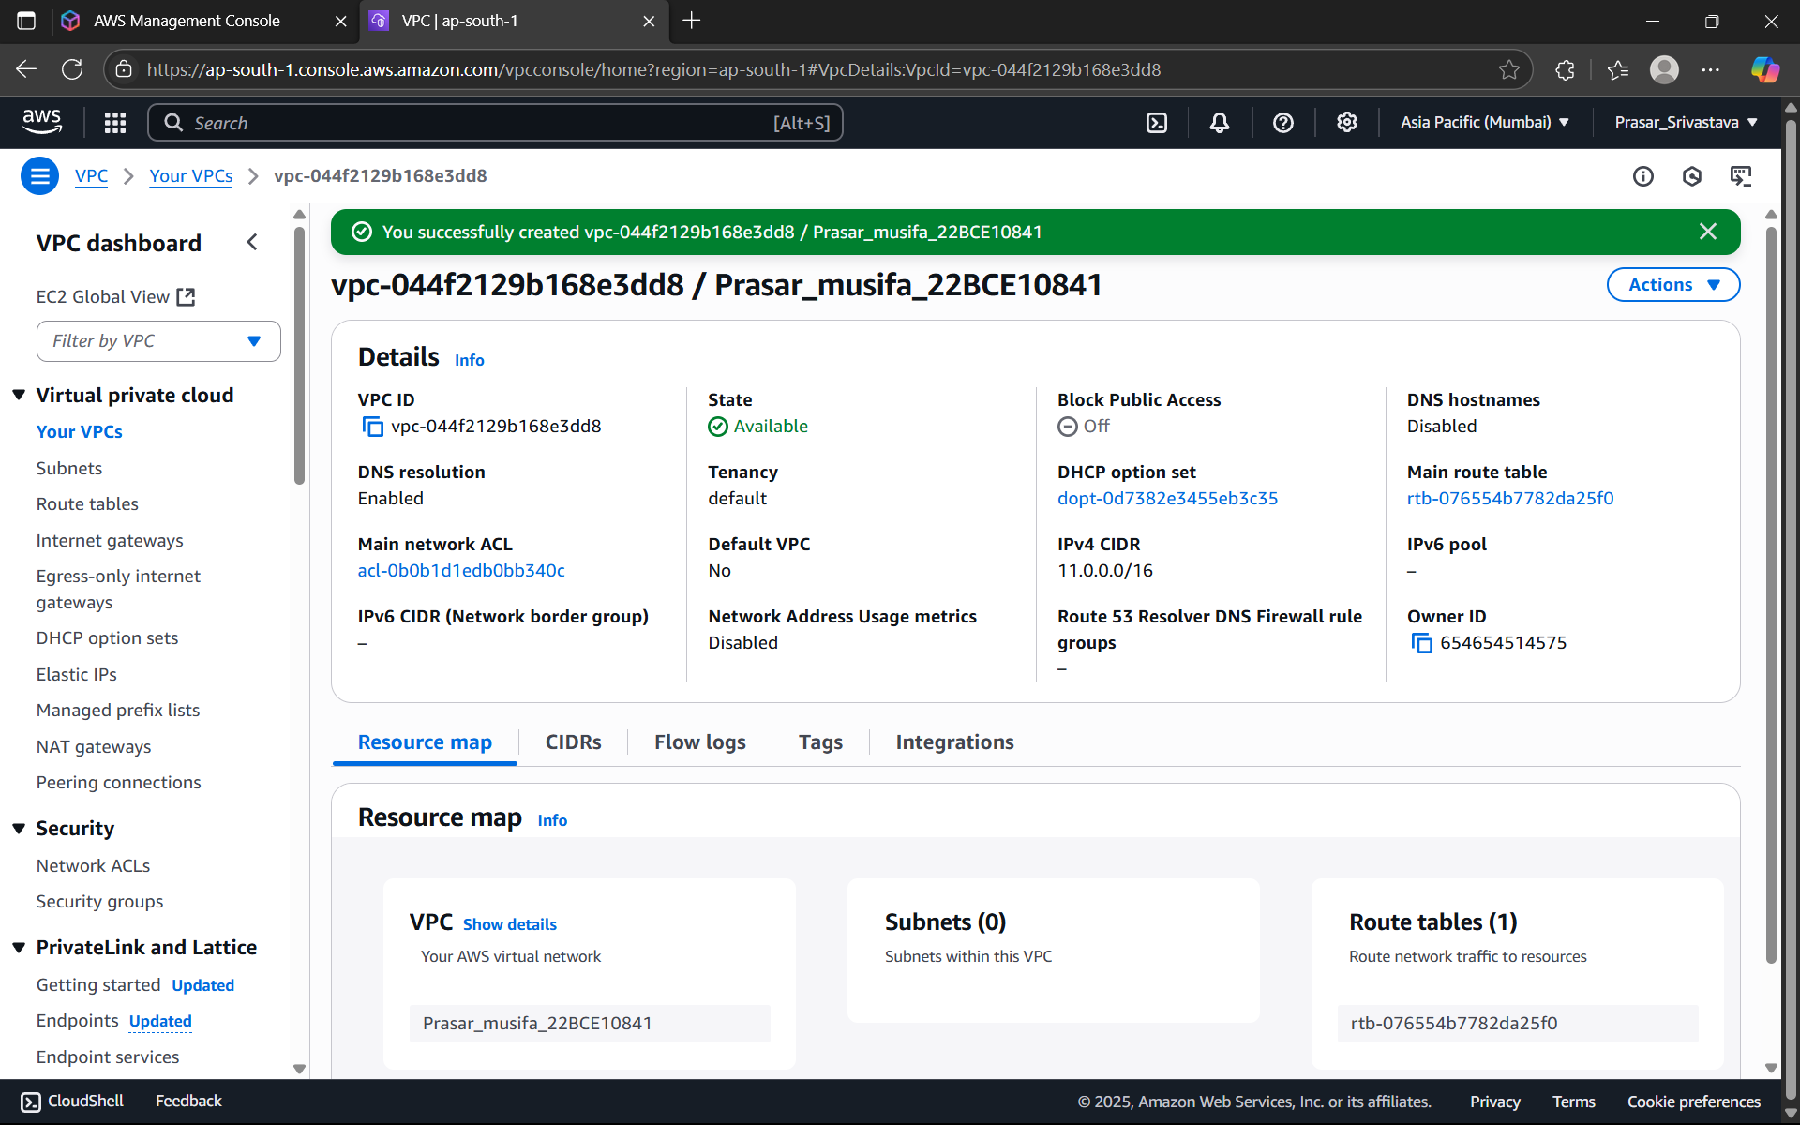

STEP6: CLICK ON SUBNET>CREATE SUBNET

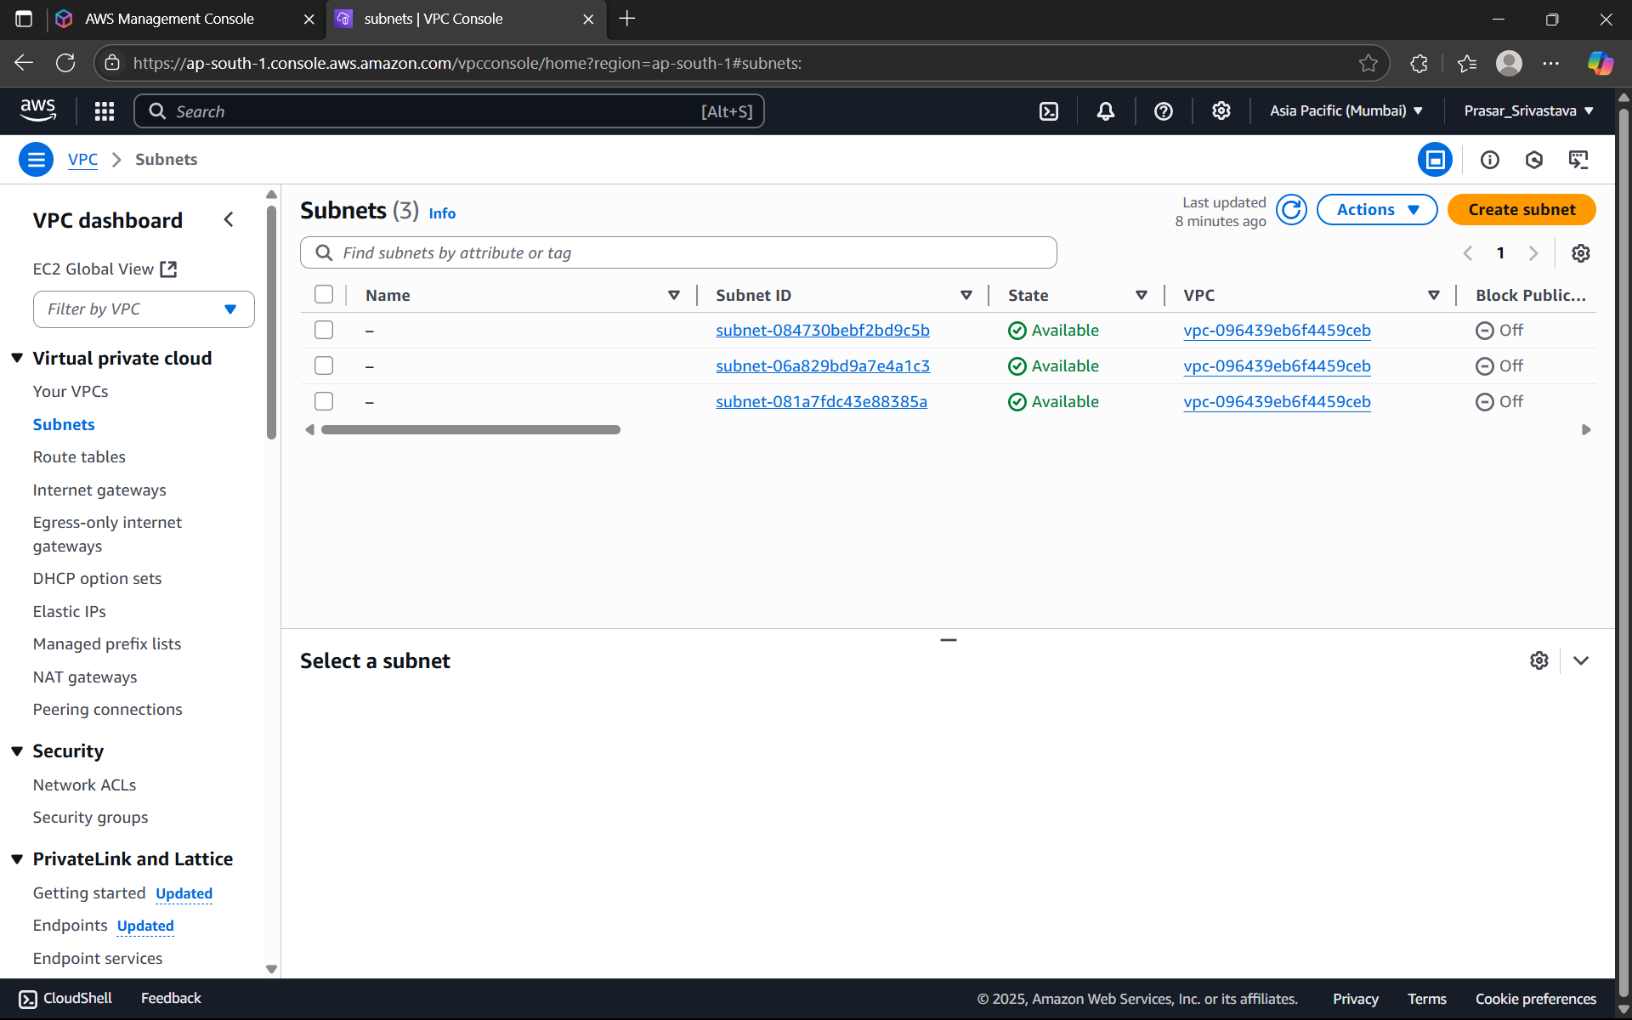

STEP7: SELECT THE VPC THAT YOU HAVE CREATED EARLIER

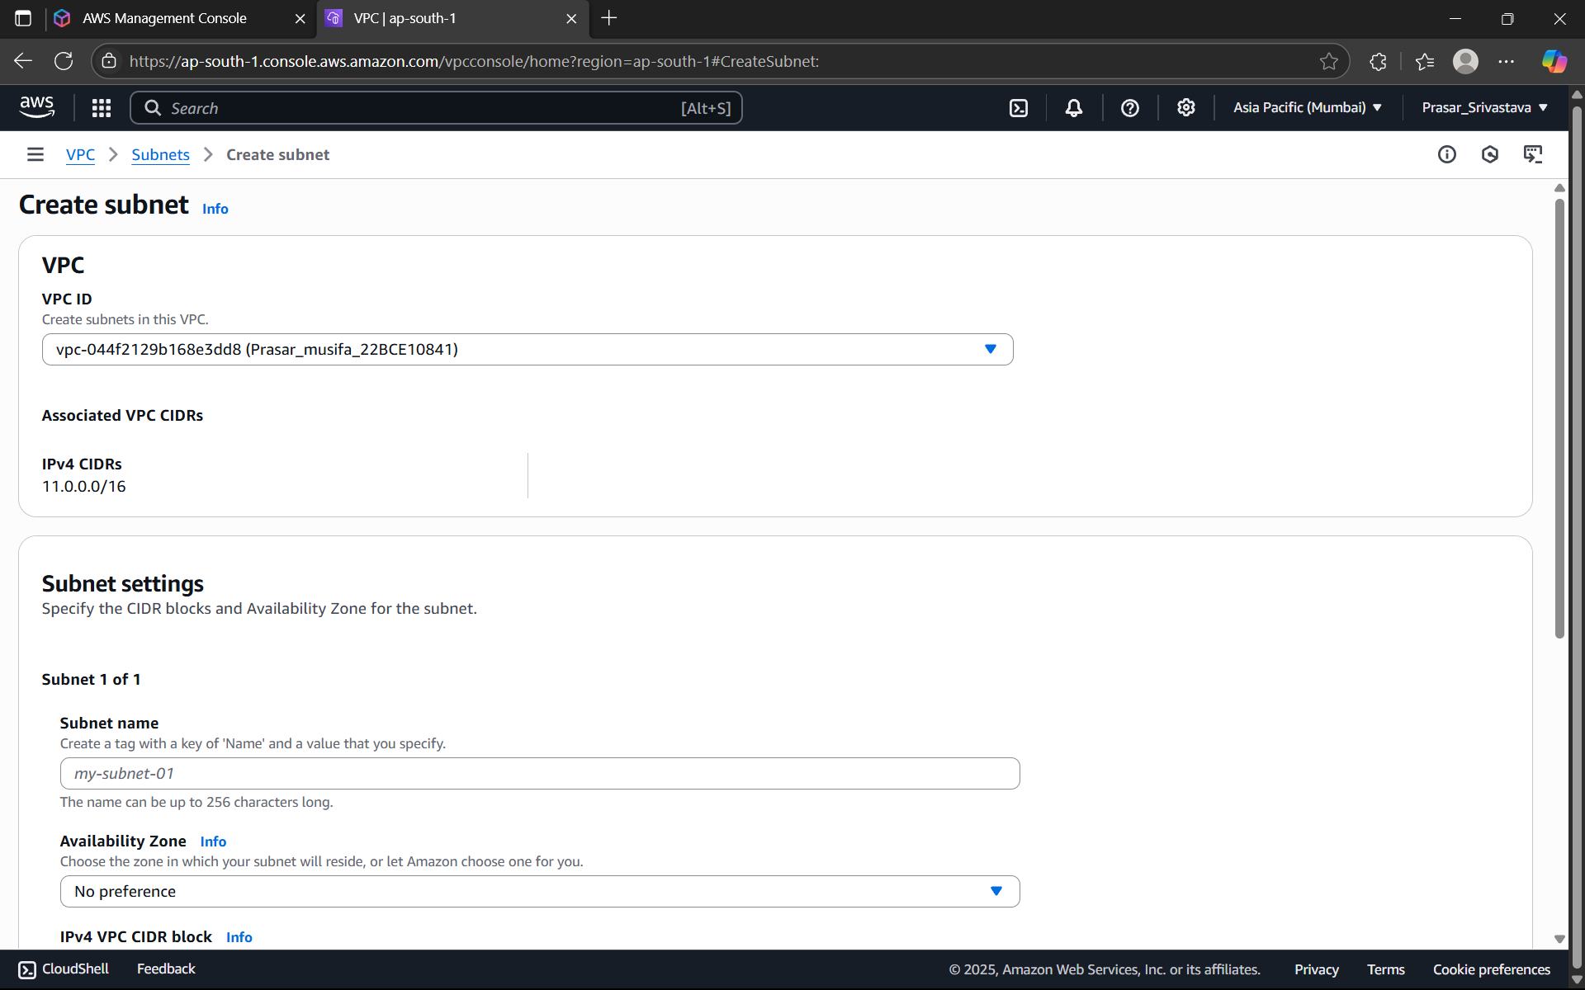

STEP8: SELECT ap-south-1a in the Availability Zone

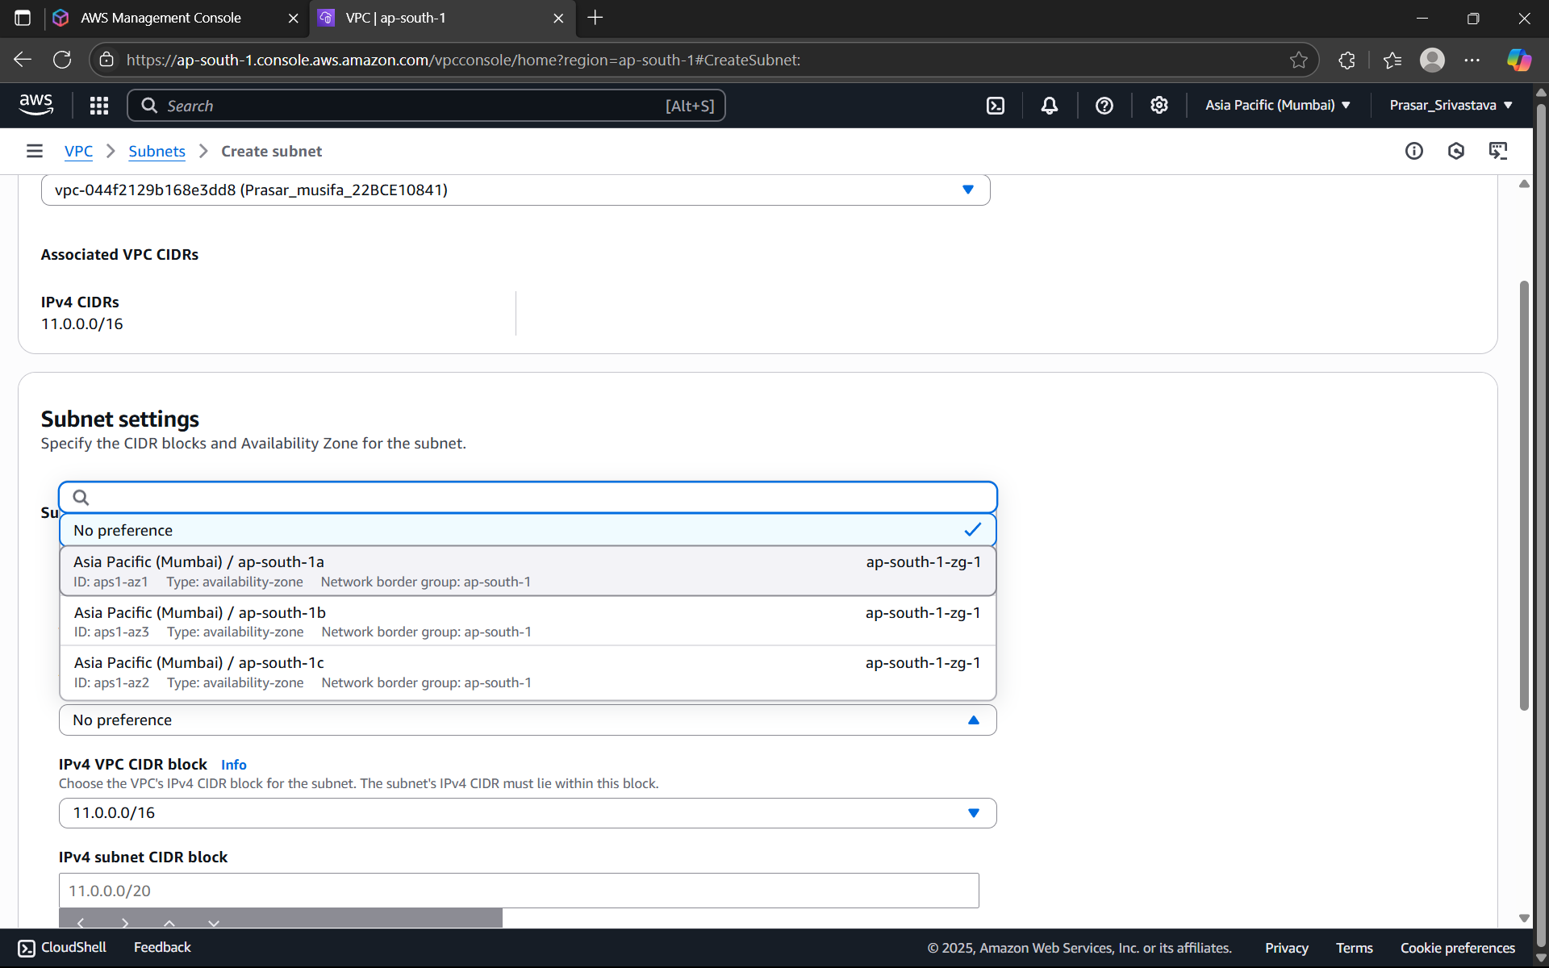

STEP9: ENTER IPv4 SUBNET CIDR BLOCK-11.0.1.0/24> CLICK ON ADD NEW SUBNET

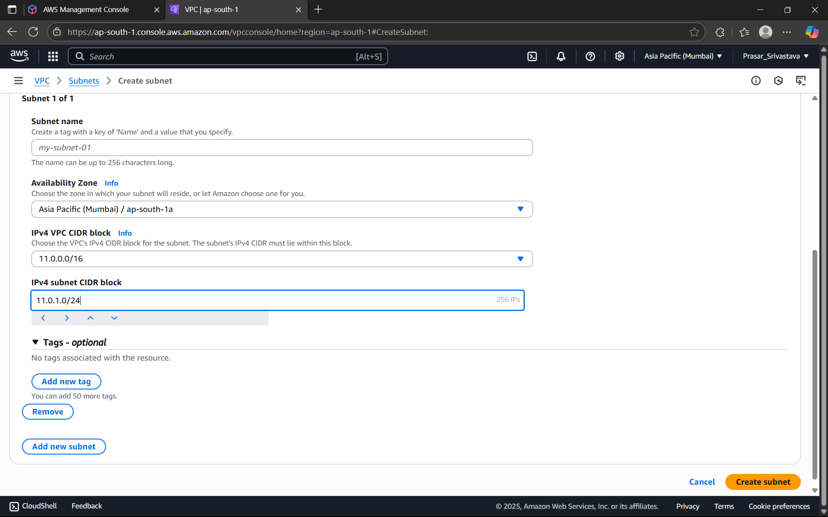

STEP9: ENTER THE NAME OF THE PRIVATE SUBNET> AVAILABILITY ZONE:ap-south-1b> IPv4

subnet CIDR Block-11.0.2.0/24> CLICK ON CREATE SUBNET

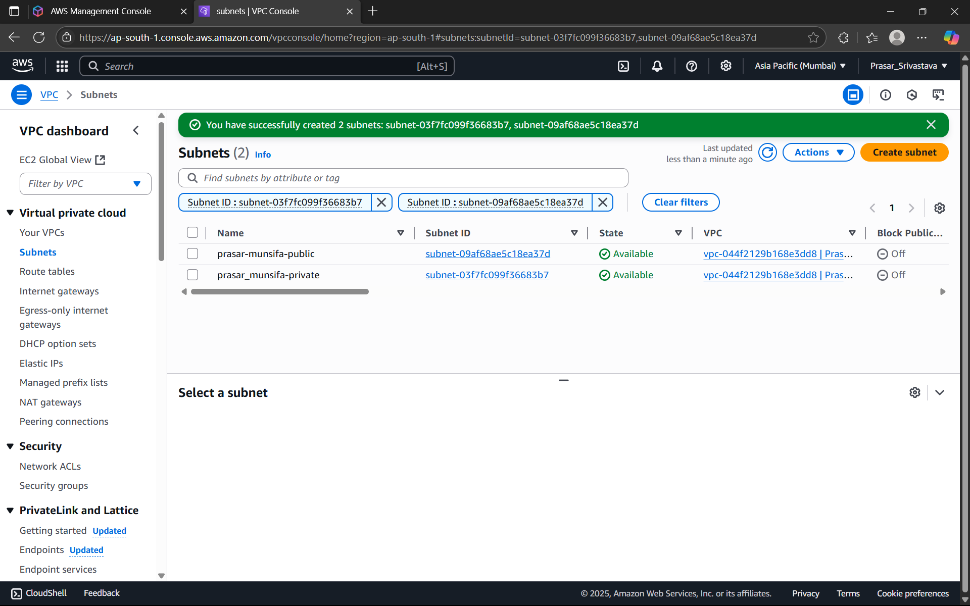

STEP10: BOTH THE PUBLIC AND PRIVATE SUBNET IS CREATED



STEP11: NOW CREATE AN INTERNET GATEWAY FOR PUBLIC SUBNET. CLICK ON INTERNET

GATEWAY FROM THE DASHBOARD> CLICK ON CREATE INTERNET GATEWAY

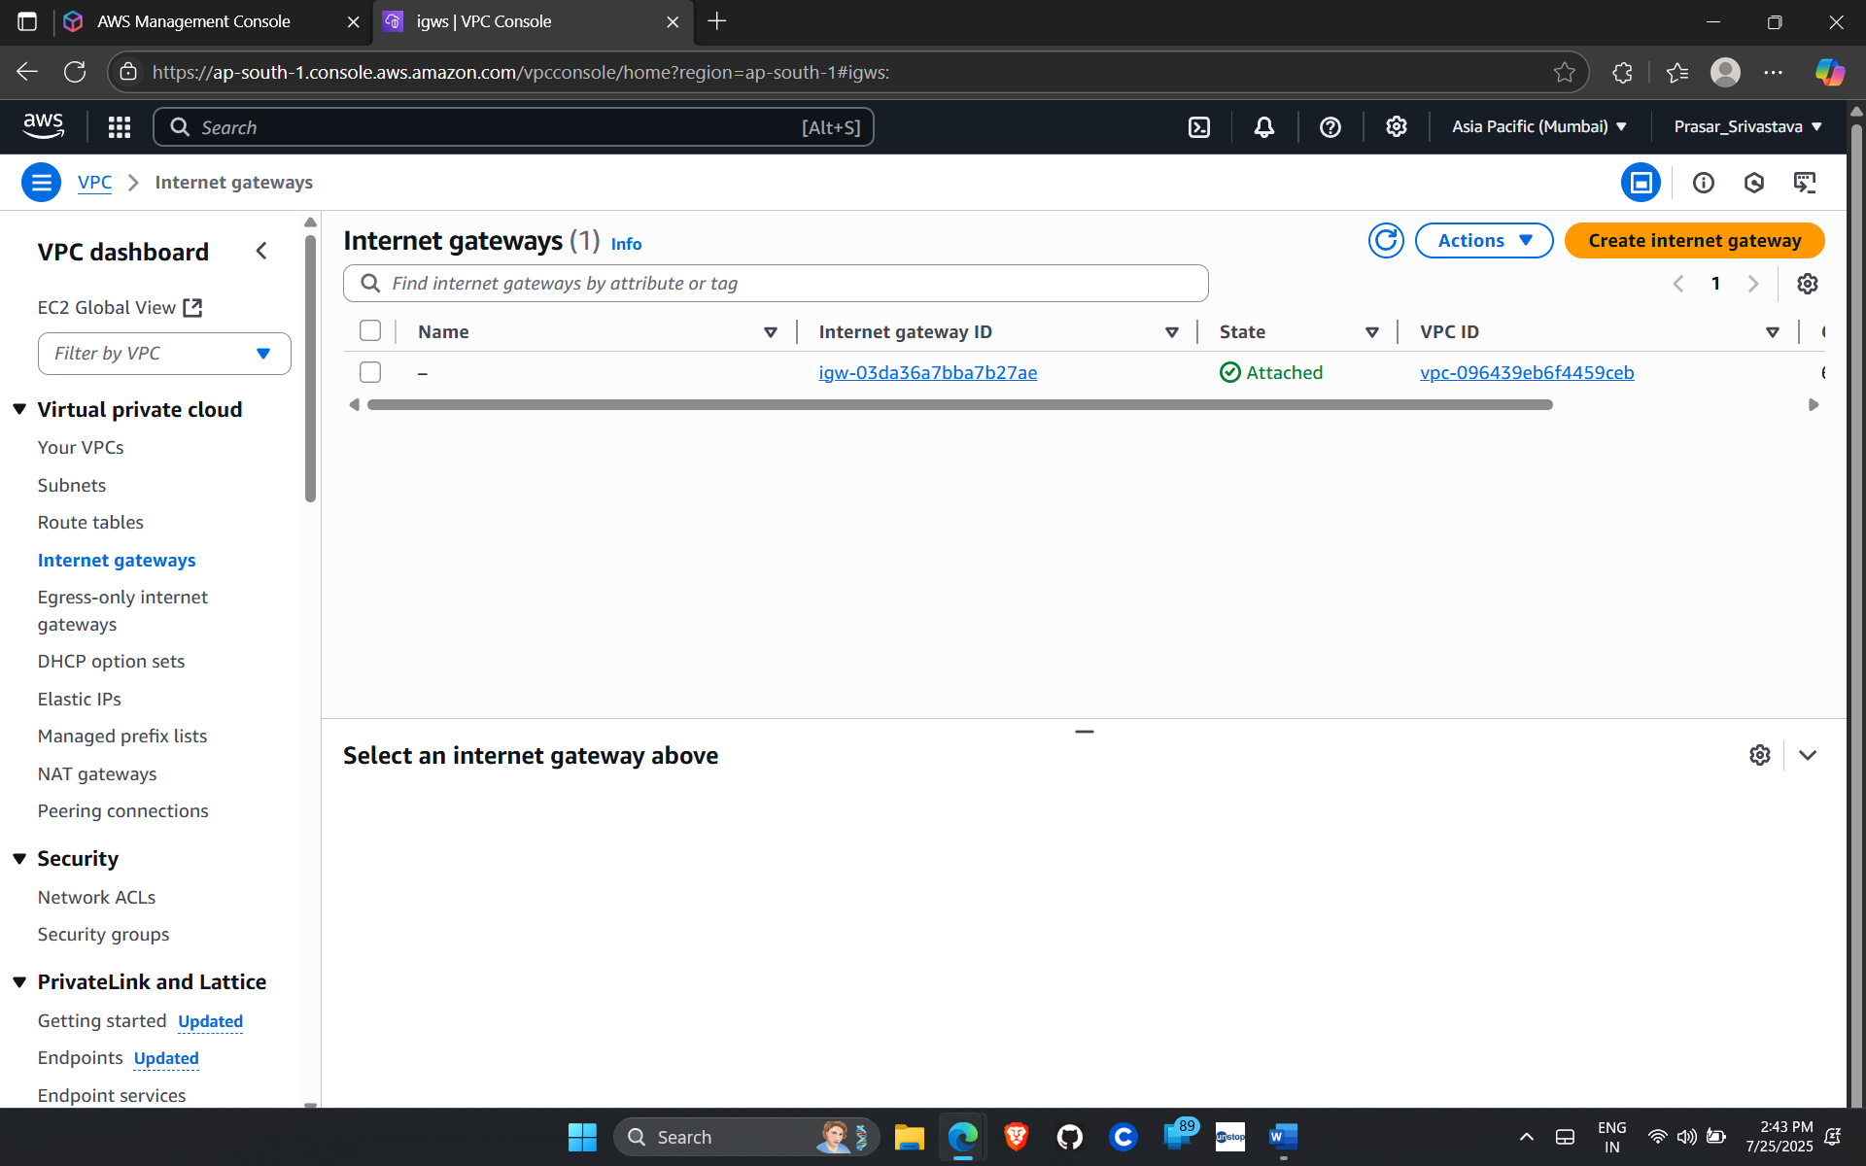

STEP12: TYPE THE NAME OF THE GATEWAY

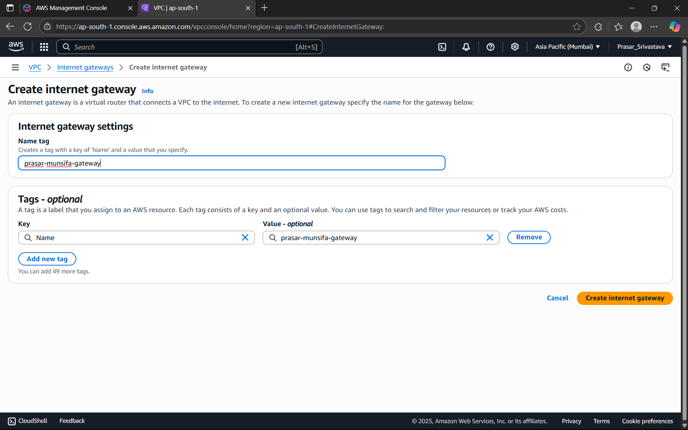

STEP13: INTERNET GATEWAY IS CREATED

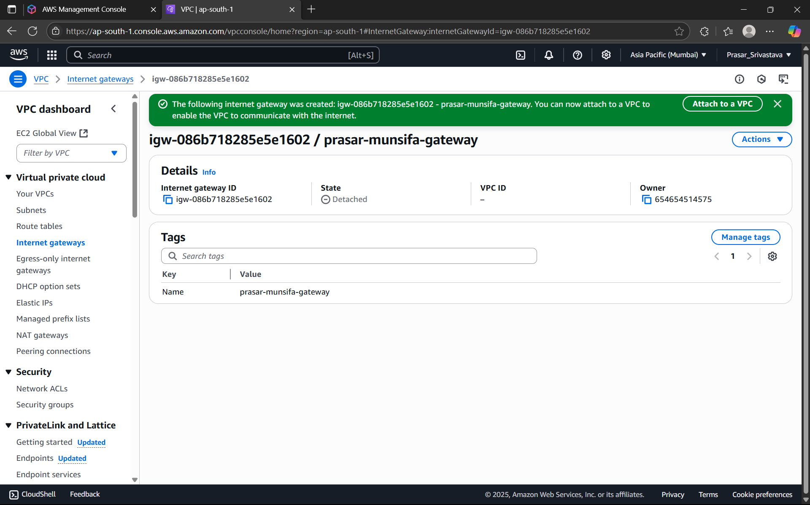

STEP14: CLICK ON ATTACH TO VPC> SELECT THE VPC CREATED EARLIER> CLICK ON ATTACH

INTERNET GATEWAY

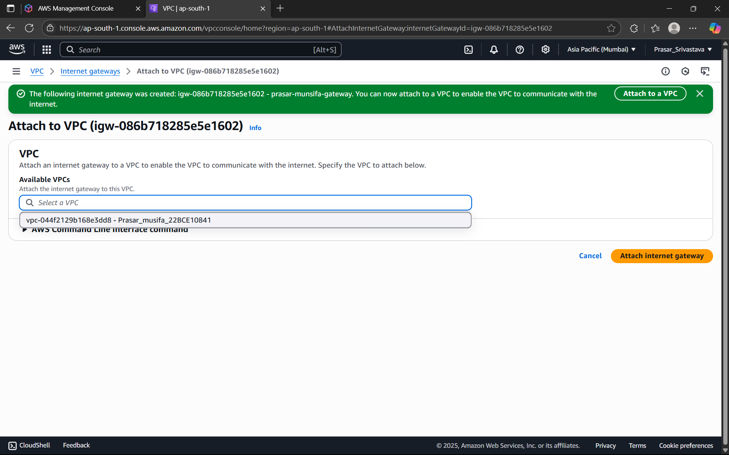

STEP15: INTERNET GATEWAY IS ATTACHED TO THE VPC

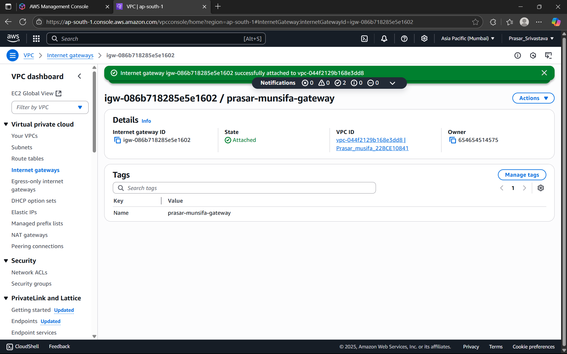

STEP16: NEXT CREATE TWO ROUTE TABLES (PRIVATE AND PUBLIC) FOR THE SUBNETS.

STEP17: TO CREATE A PUBLIC ROUTE TABLE: CLICK ON ROUTE TABLES>CREATE A ROUTE

TABLE> WRITE A SUITABLE NAME FOR THE ROUTE TABLE>CHOOSE THE VPC>CLICK ON

CREATE ROUTE TABLE

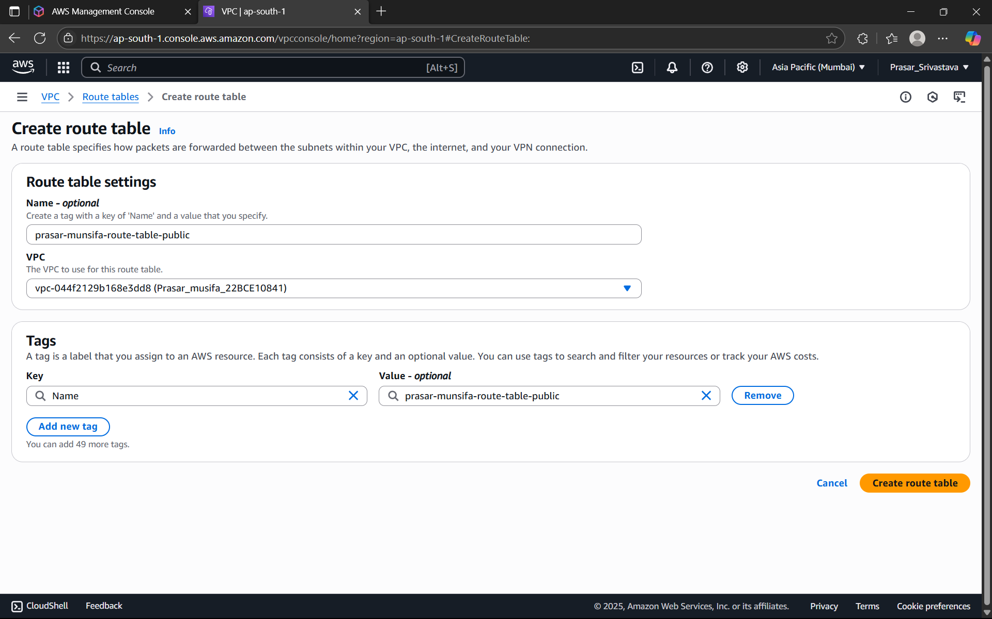

STEP18: TO CREATE A PRIVATE ROUTE TABLE: CLICK ON ROUTE TABLES>CREATE A ROUTE

TABLE> WRITE A SUITABLE NAME FOR THE ROUTE TABLE>CHOOSE THE VPC>CLICK ON

CREATE ROUTE TABLE

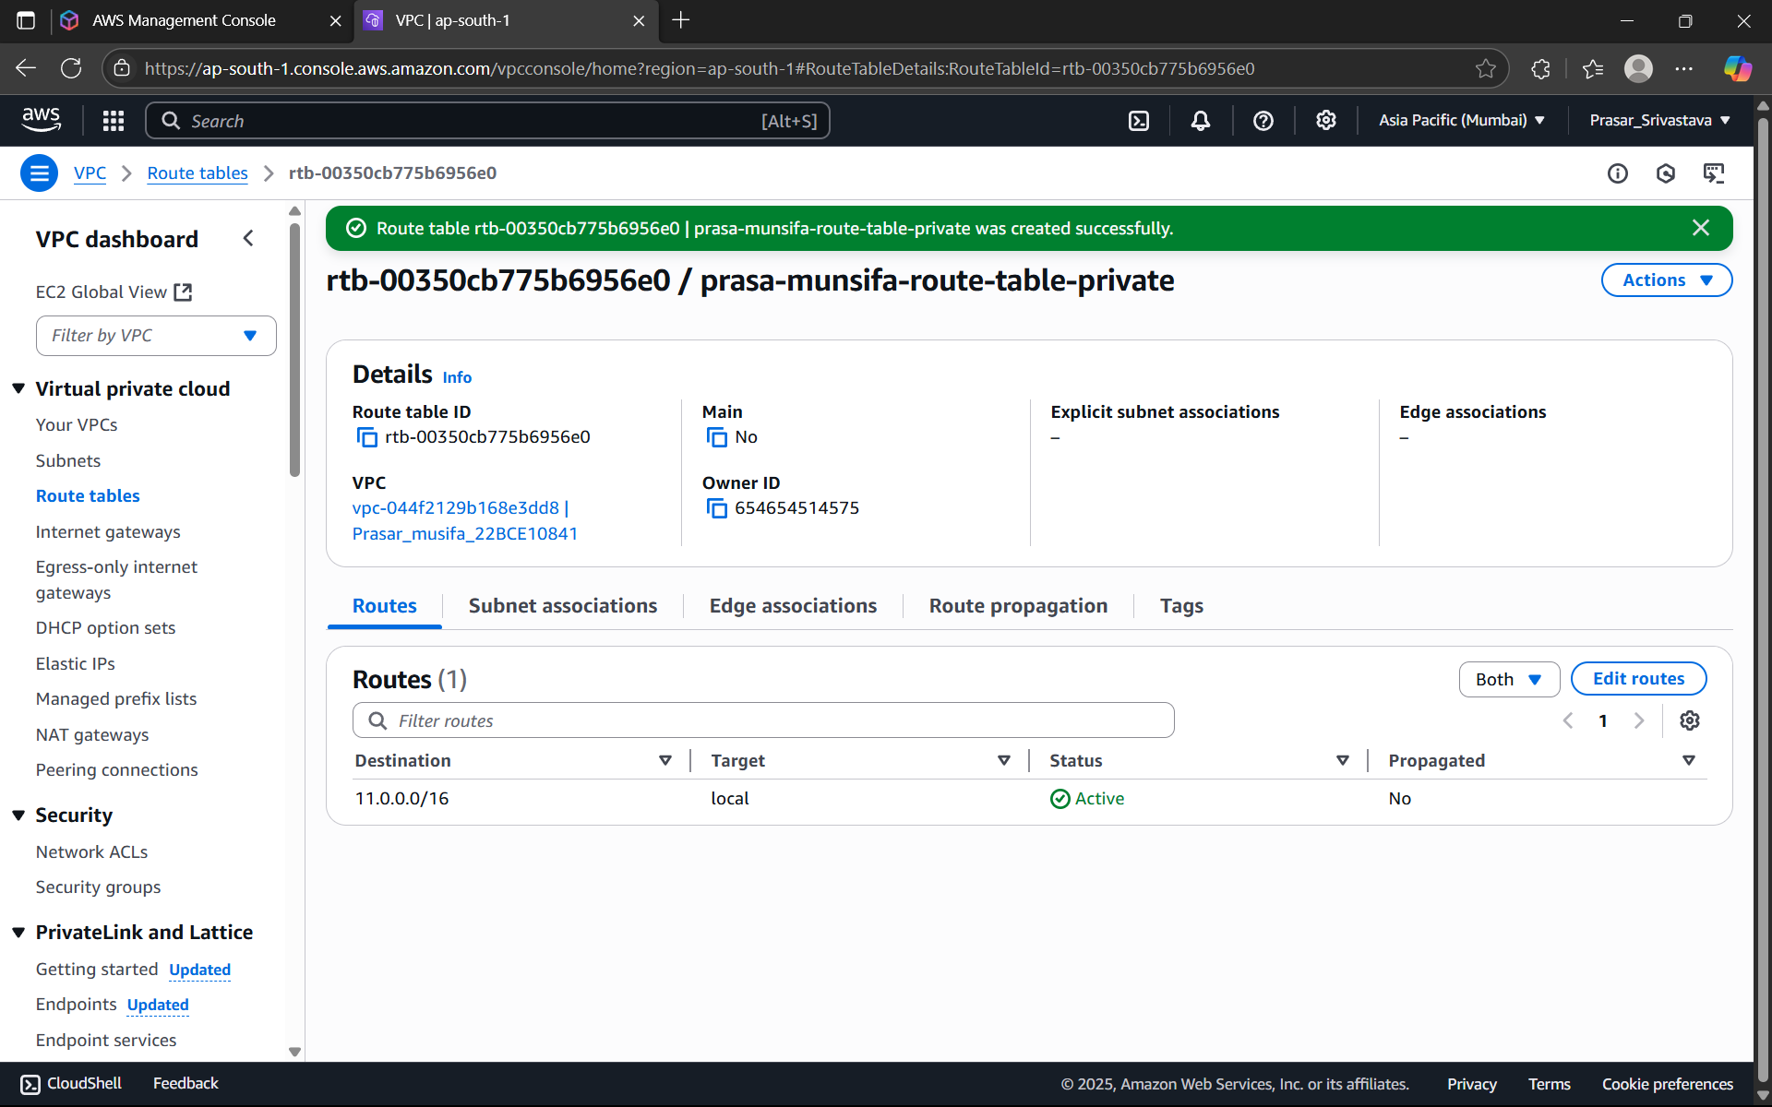

STEP19: BOTH THE PUBLIC AND PRIVATE ROUTE TABLES ARE CREATED AS SHOWN BELOW.

NOW WE NEED TO CONNECT BOTH THE ROUTE TABLES WITH THEIR CORRESPONDING

SUBNETS.

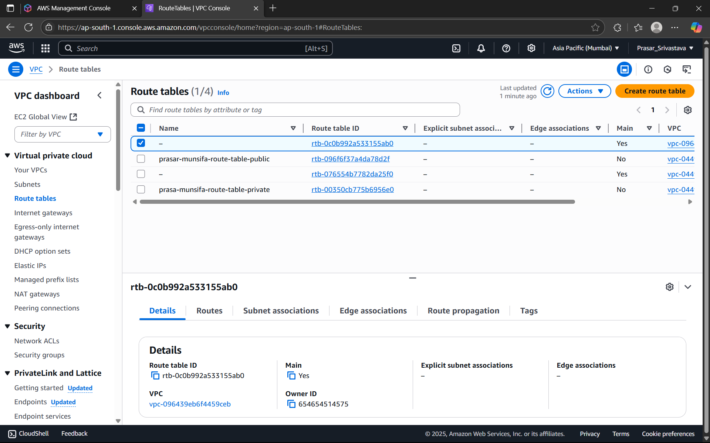

STEP20: CLICK ON THE PUBLIC ROUTE TABLE>CLICK ON SUBNET ASSOCIATIONS

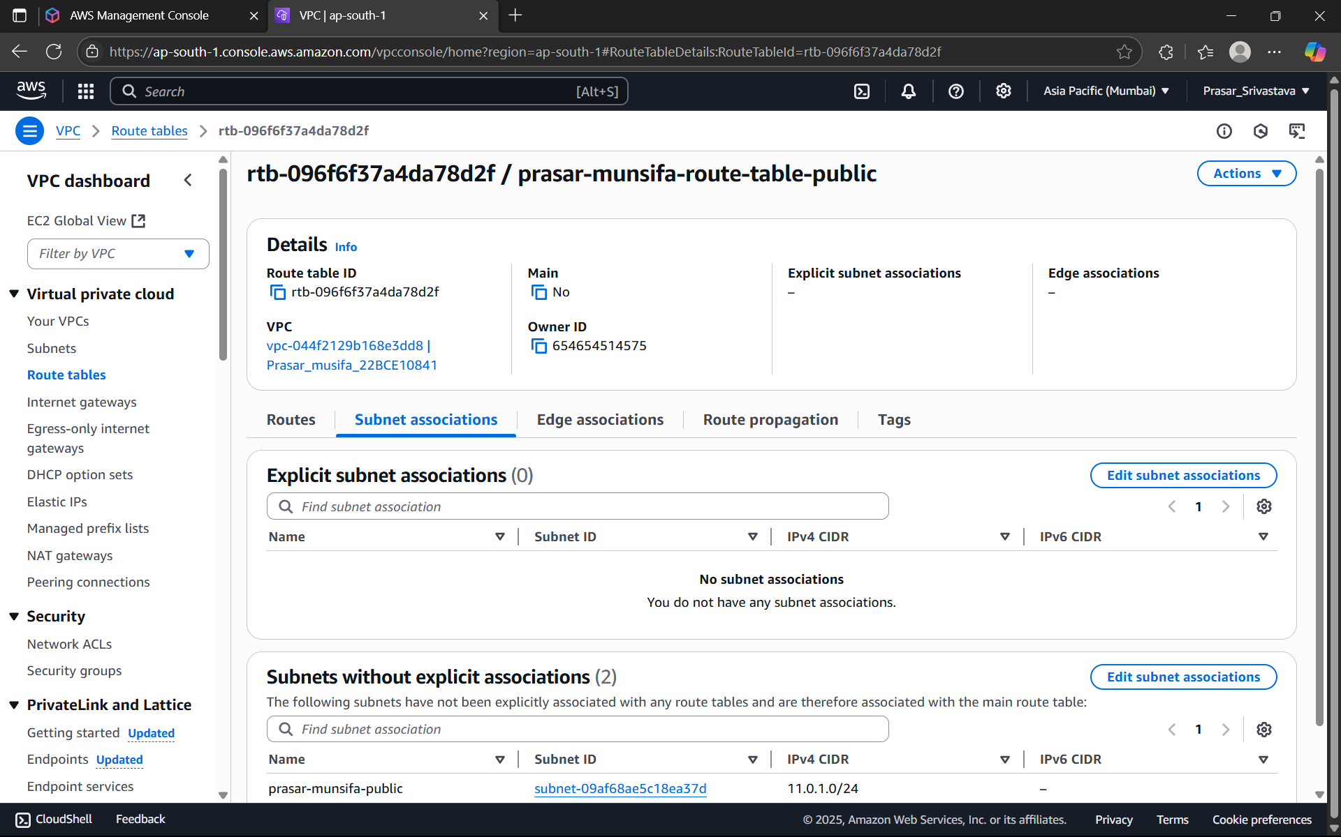

STEP 21: CLICK ON EDIT SUBNET ASSOCIATIONS > CHOOSE PUBLIC SUBNET FROM THE

OPTIONS> CLICK ON SAVE ASSOCIATIONS

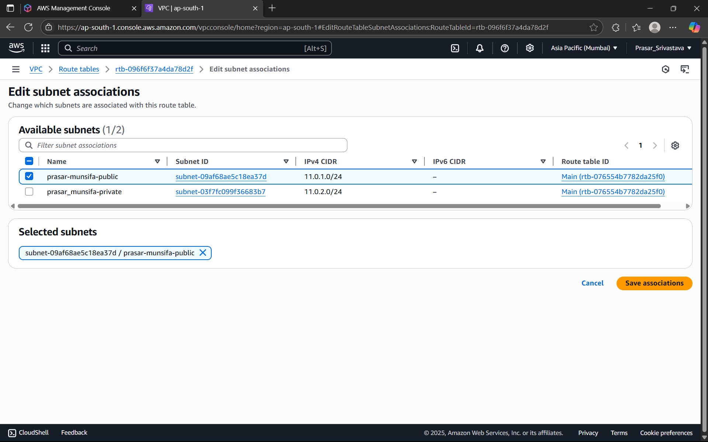

STEP 21: SUBNET ASSOCIATION IS DONE. REPEAT THE SAME STEP FOR PRIVATE SUBNET

ASSOCIATION.

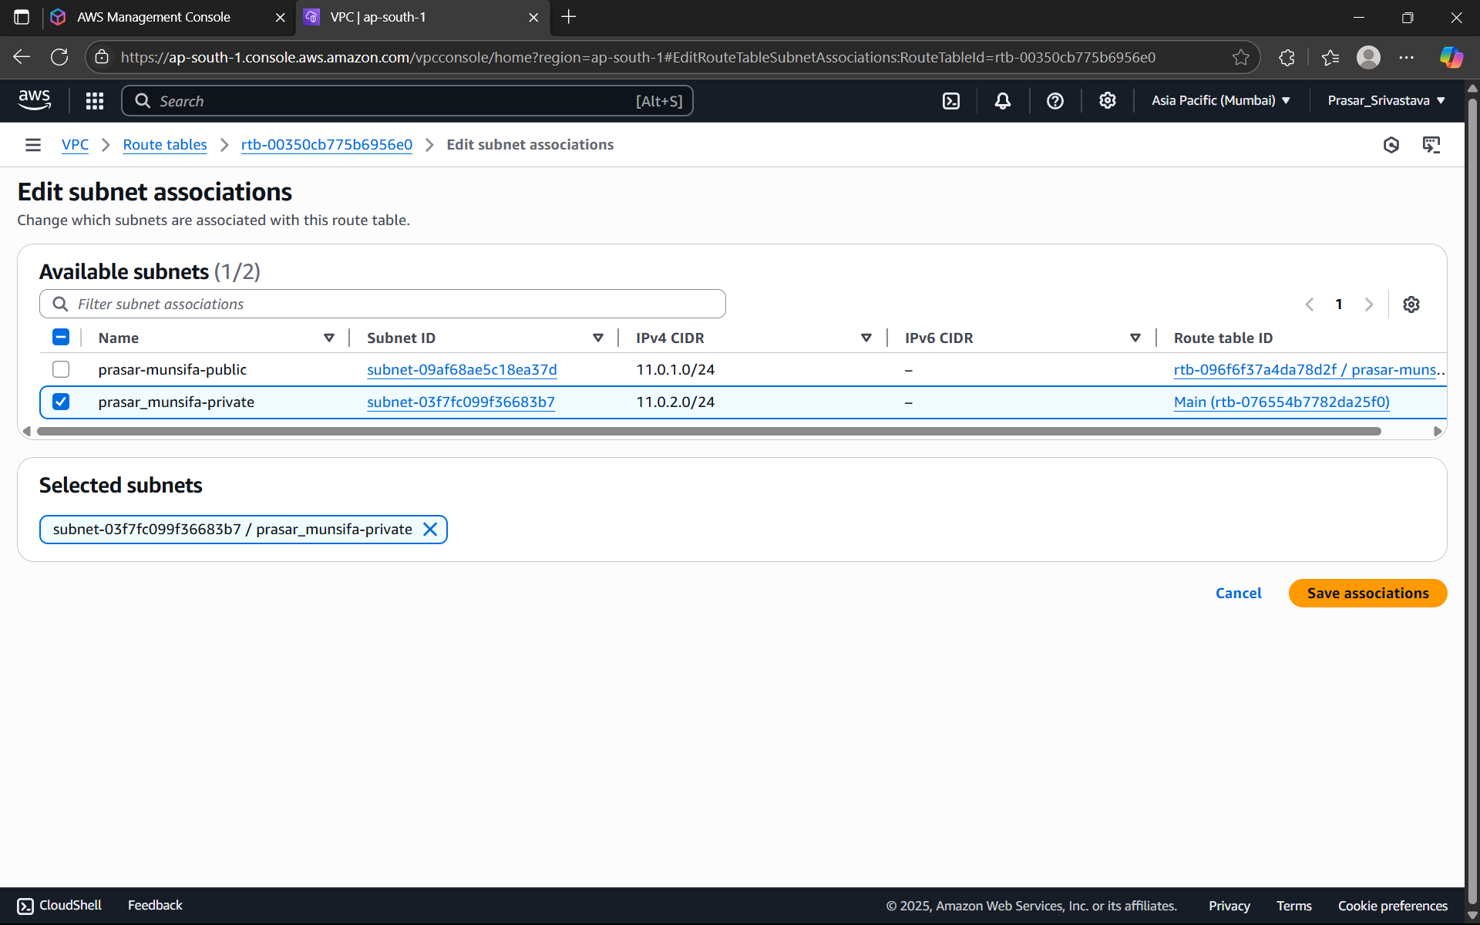

STEP22: NEXT WE NEED TO CREATE THE ROUTE SO THAT INTERNET CAN BE ACCESSED

WITH THE HELP OF INTERNET GATEWAY THROUGH THESE ROUTE TABLES.

STEP23: GO TO PUBLIC ROUTE TABLE FROM THE AWS CONSOLE> CLICK ON ROUTES>CLICK

ON EDIT ROUTES

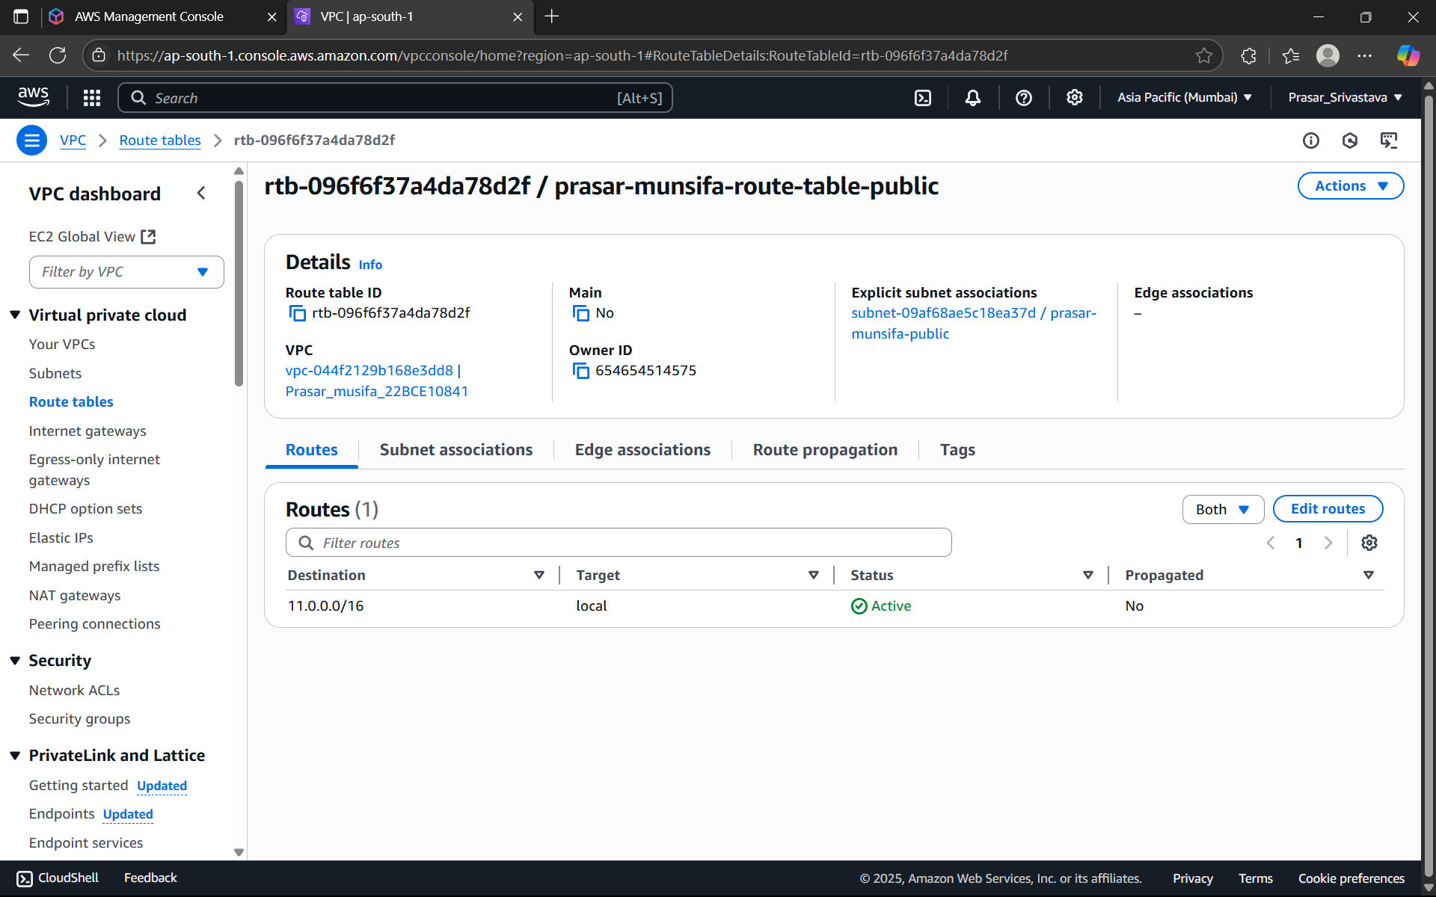

STEP24: CLICK ON ADD ROUTE>SELECT THE IP-0.0.0.0/0>CHOOSE INTERNET GATEWAY>

SELECT THE INTERNET GATEWAY THAT YOU HAVE CREATED> CLICK ON SAVE CHANGES

(NOTE:0.0.0.0/0 means it allows all the IP addresses to access the resources present in the

public subnet)

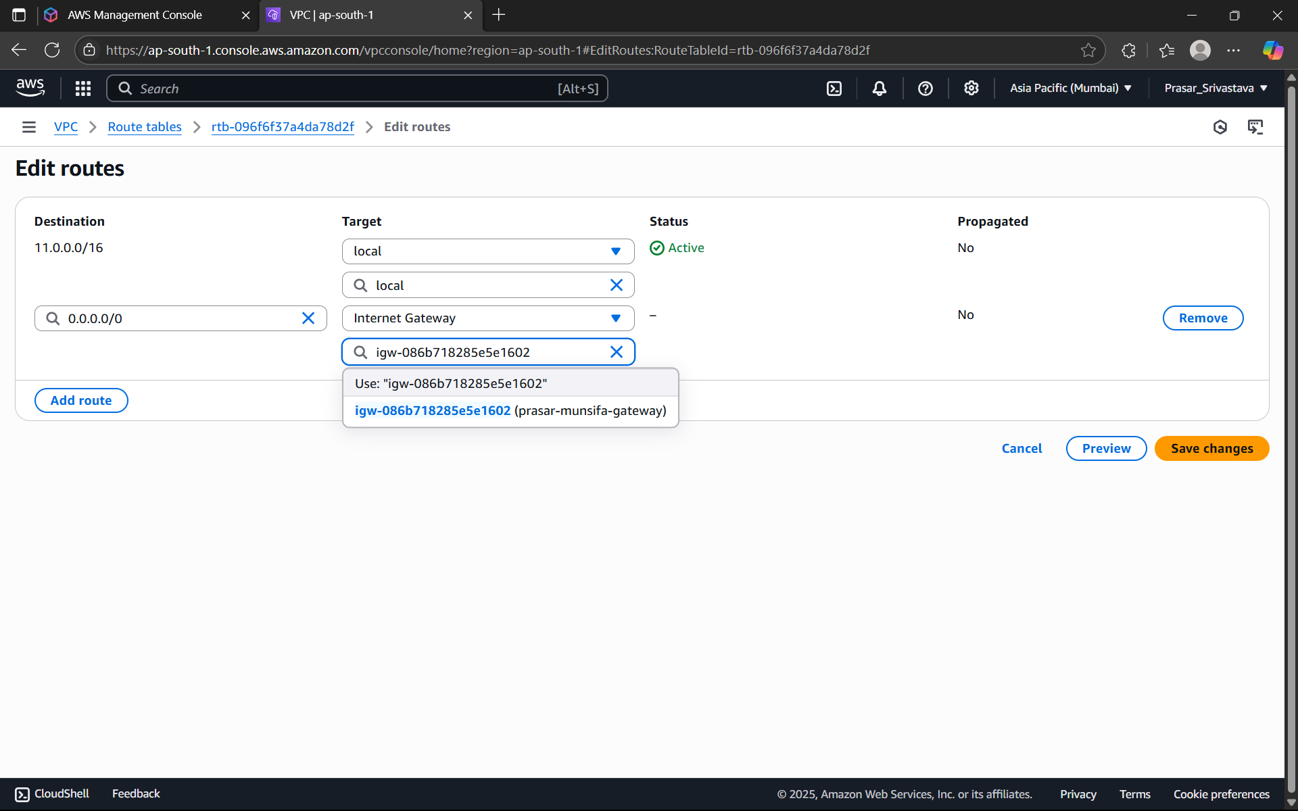

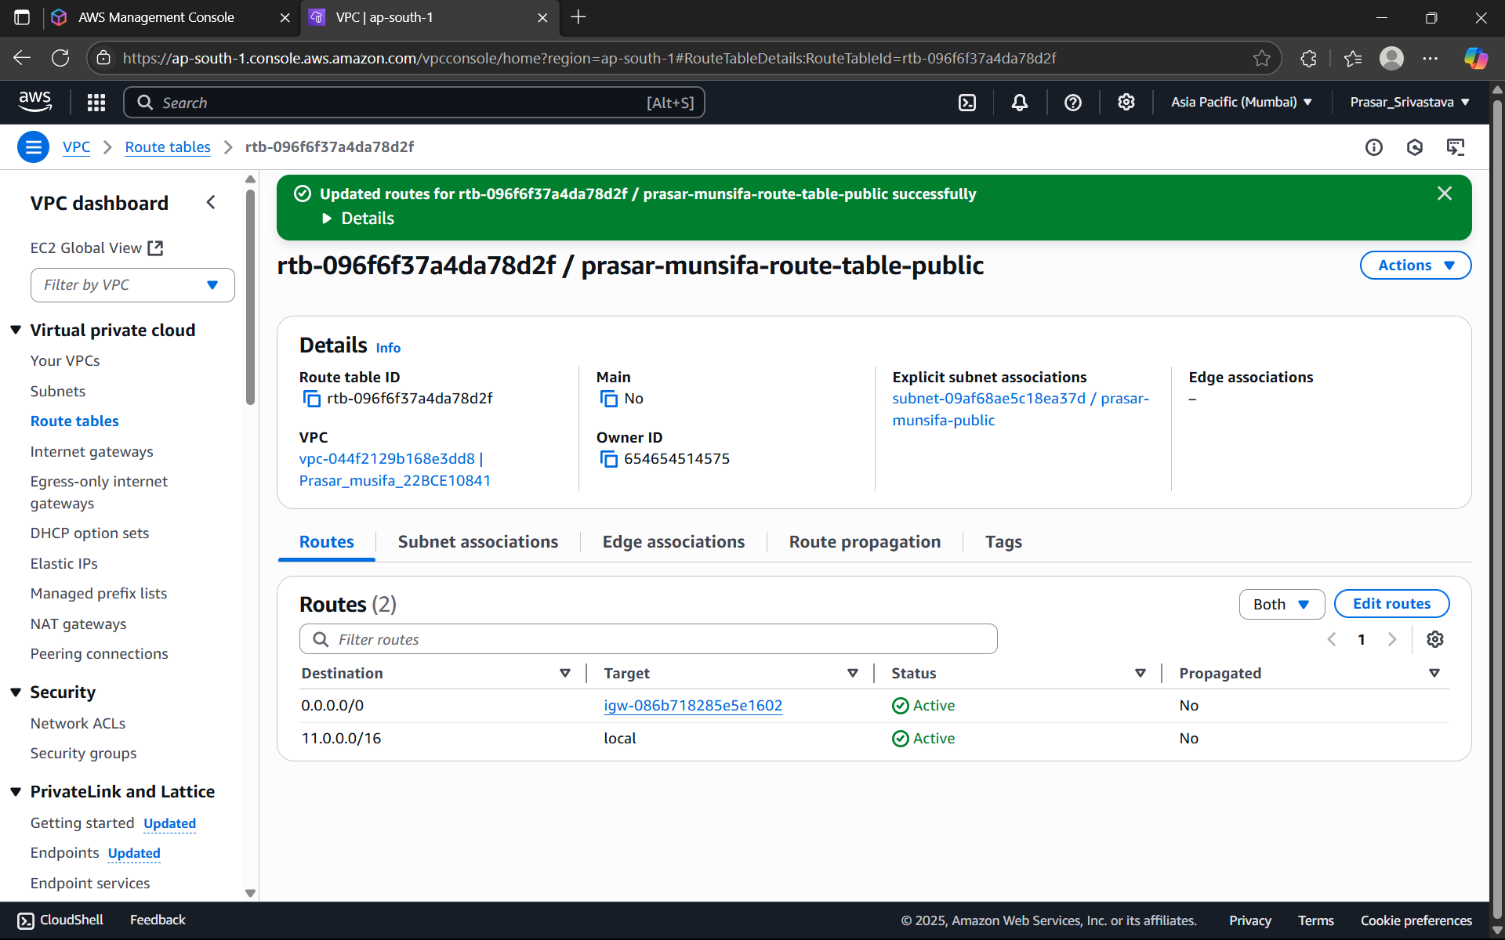

STEP25: WE NEED TO CREATE THE NAT GATEWAY FOR THE PRIVATE SUBNET SO THAT

RESOURCES PRESENT INSIDE THE PRIVATE SUBNET CAN ACCESS THE INTERNET WITH THE

HELP OF INTERNET GATEWAY.

NOTE:

1. Internet Gateway is two-way process i.e., outside world can access the resources

inside the public subnet as well as resources inside it can request for accessing

outside.

2. NAT GATEWAY is not free and its created only in public subnet.

3. Private subnet will be able to access the NAT gateway with the help of its route table

to access resources inside the public subnet.

STEP26: CLICK ON NAT GATEWAYS FROM THE DASHBOARD> CLICK ON CREATE NAT

GATEWAY.

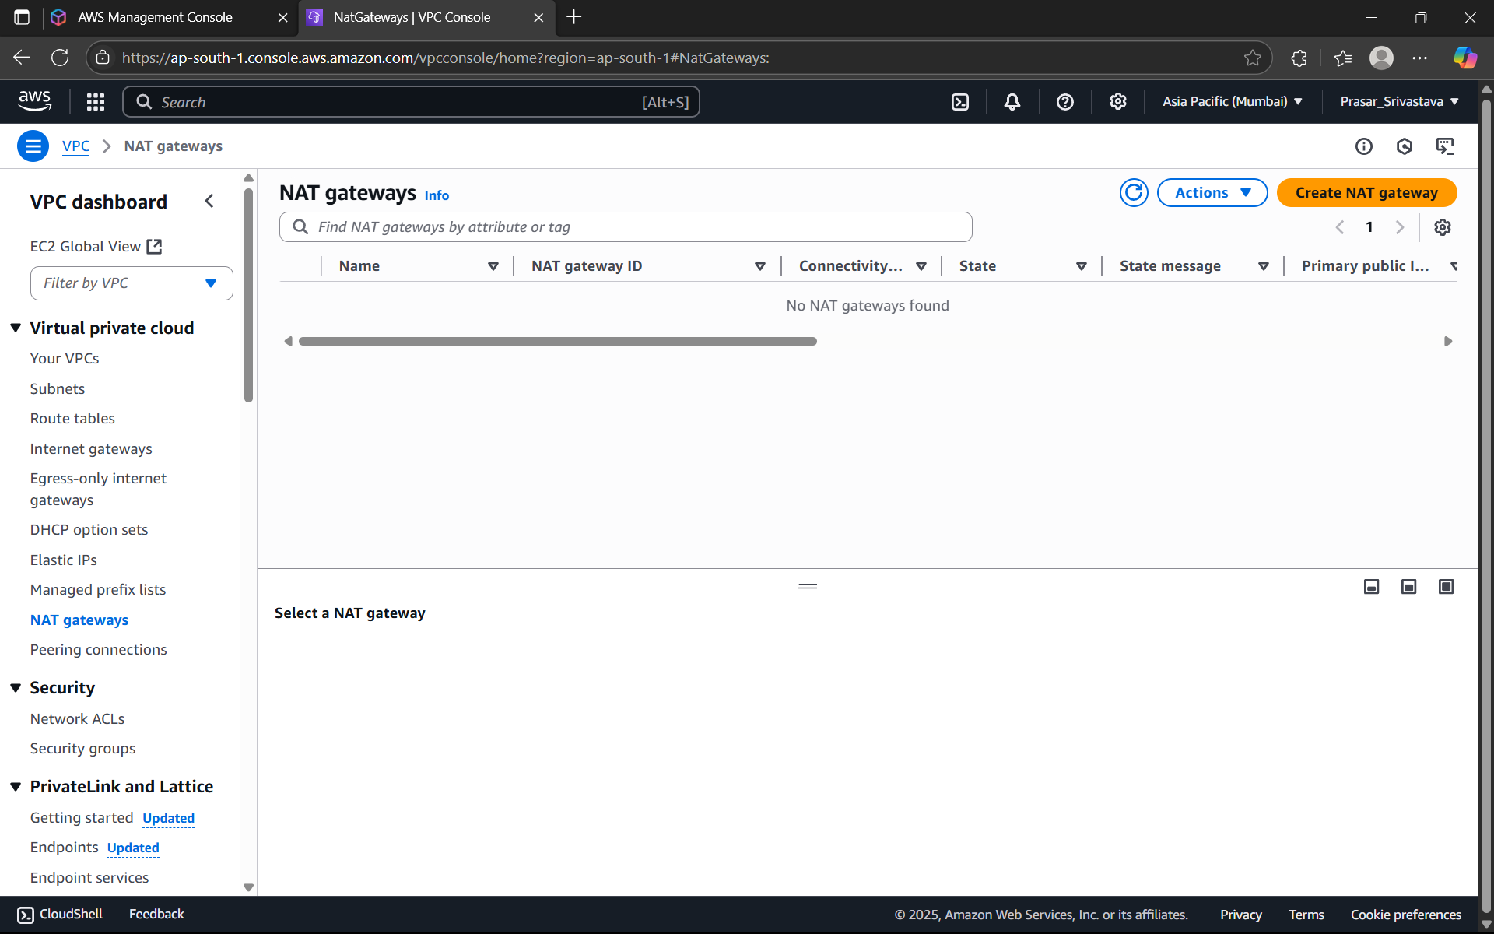

STEP27: GIVE A NAME TO THE NAT GATEWAY>CHOOSE THE PUBLIC SUBNET>ALLOCATE

ELASTIC IP> CLICK ON CREATE NAT GATEWAY.

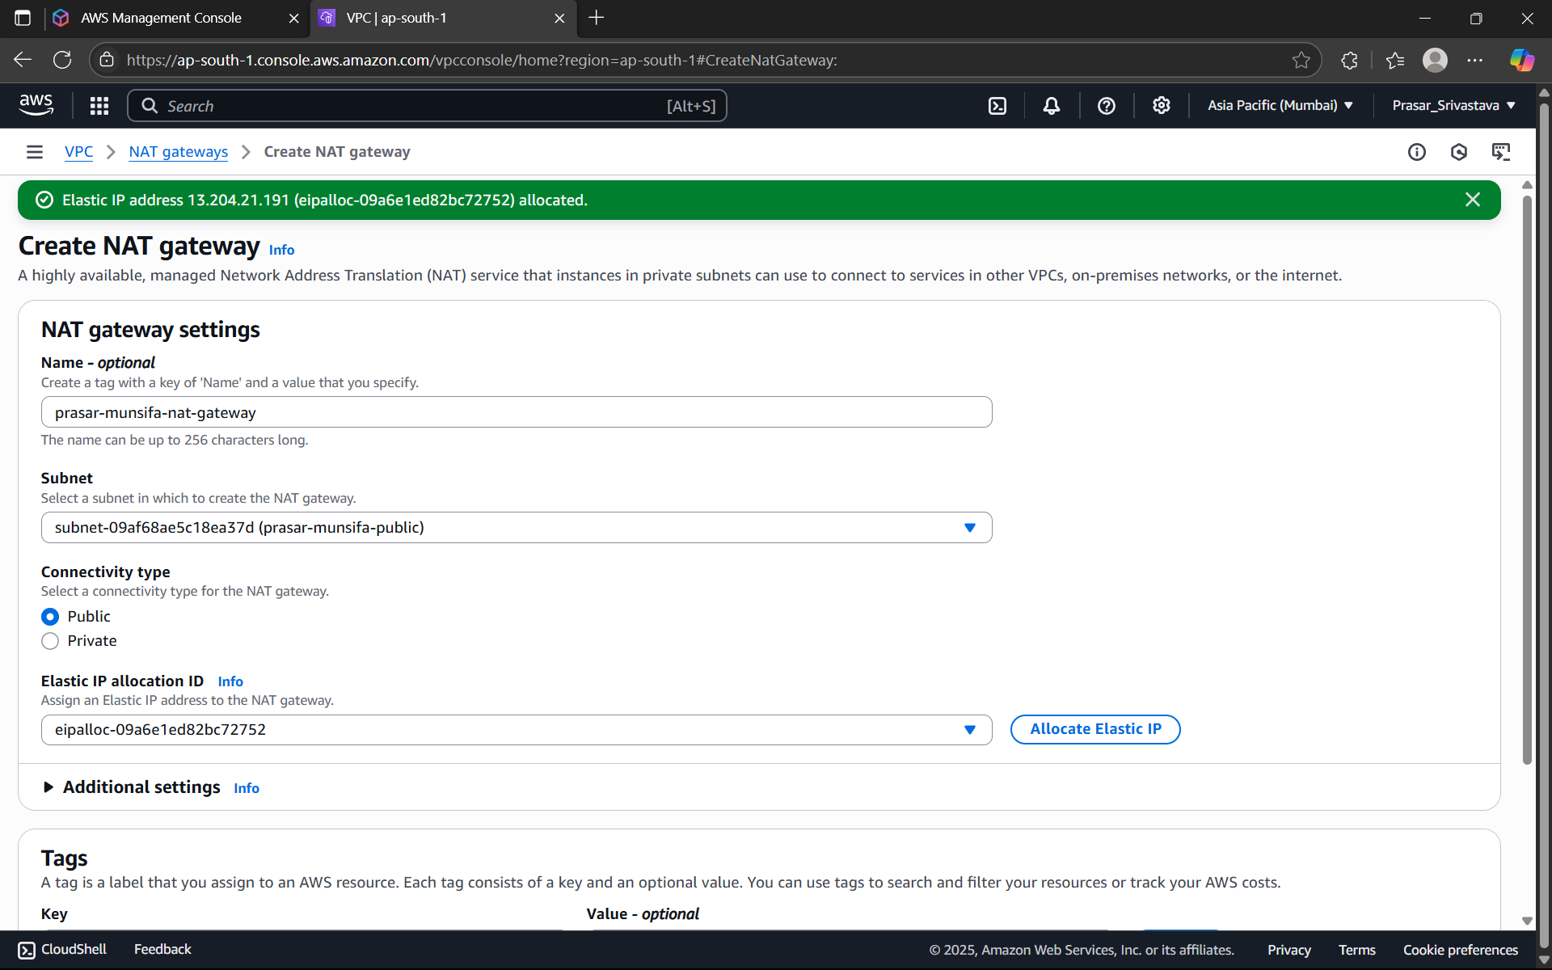

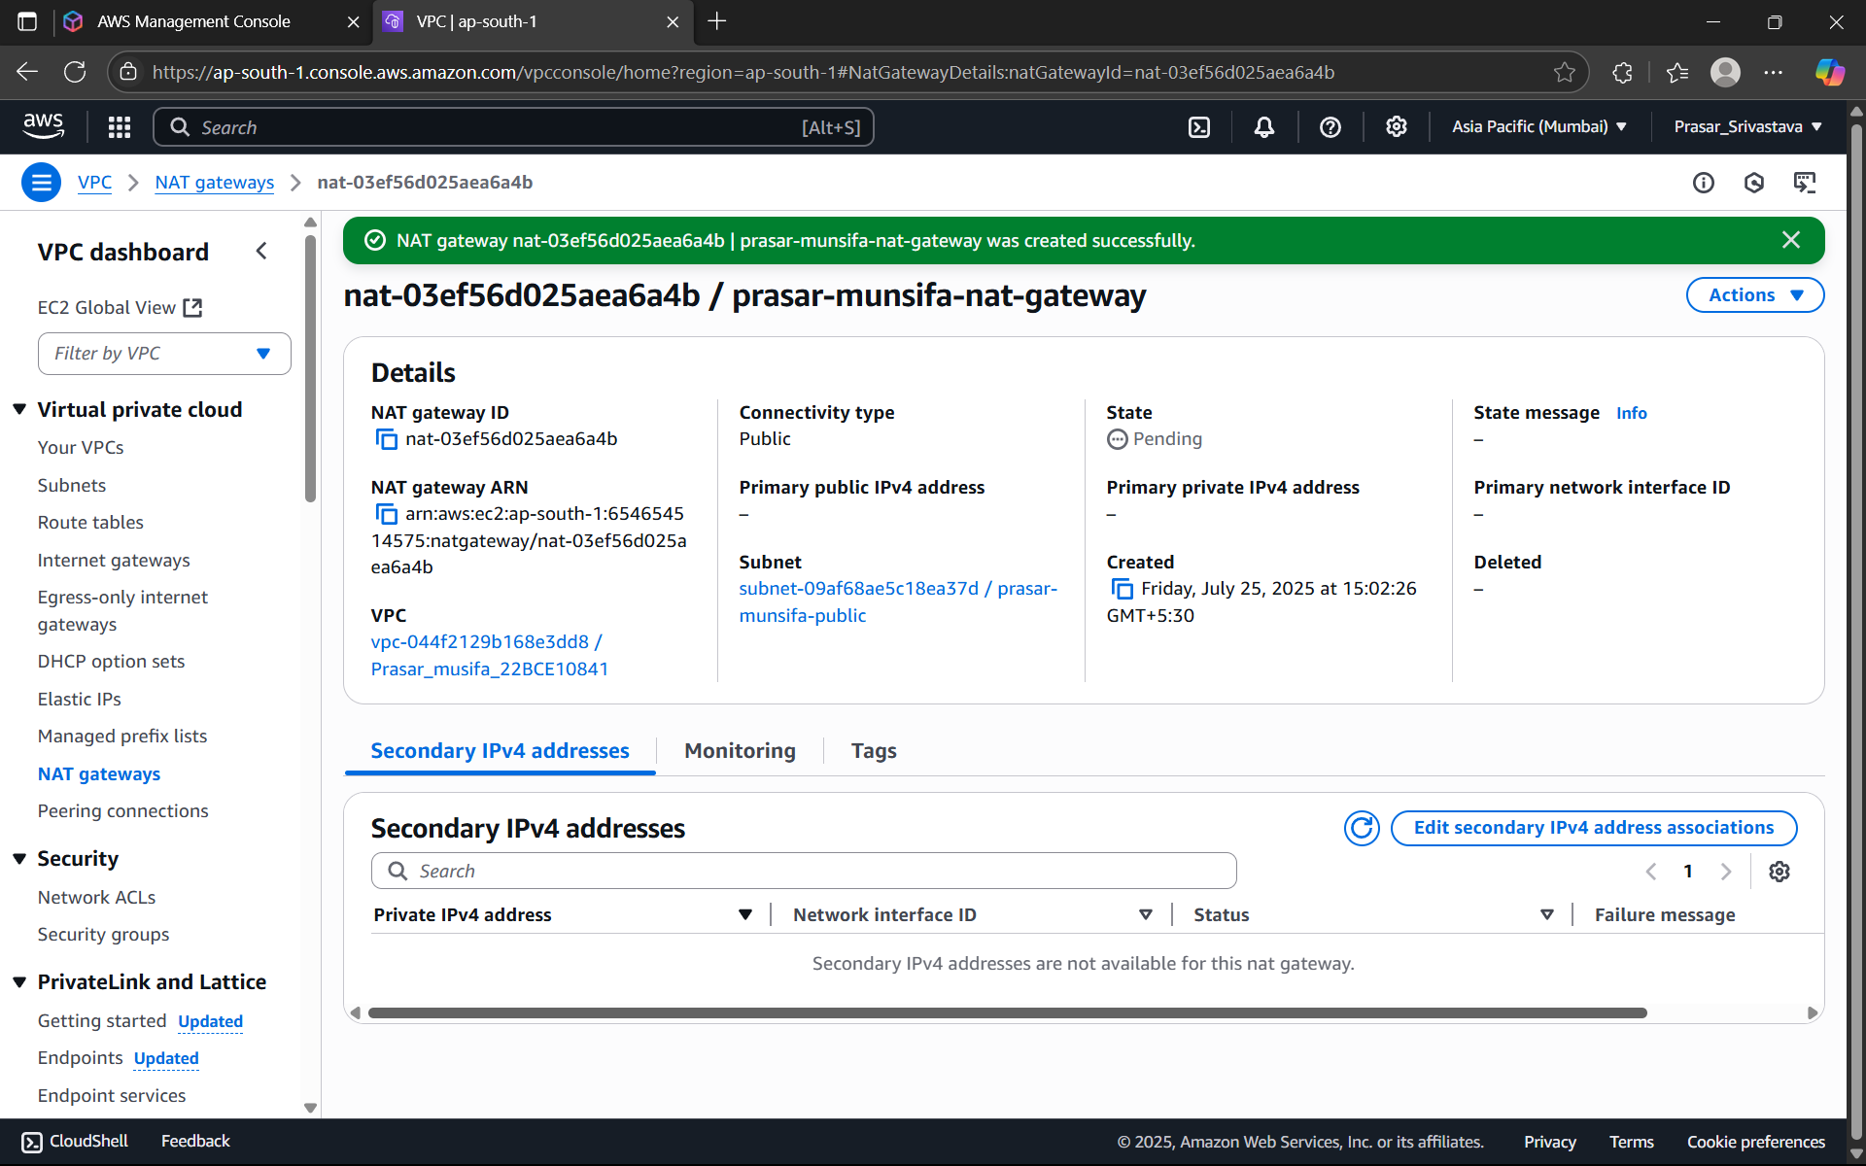

STEP28: NOW UPDATE THE PRIVATE ROUTE TABLE: CLICK ON THE ROUTE TABLES>CLICK ON

THE PRIVATE ROUTE TABLE>CLICK ON ROUTES>CLICK ON EDIT ROUTES

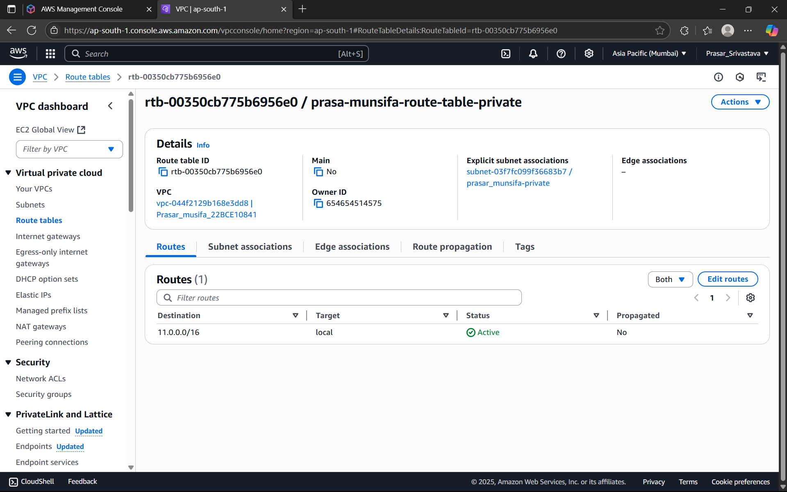

STEP29: CLICK ON ADD ROUTE>SELECT IP ADDRESS

:0.0.0.0/0>SELECT NAT GATEWAY>CHOOSE THE NAT GATEWAY THAT YOU HAVE CREATED>

CLICK ON SAVE CHANGES.

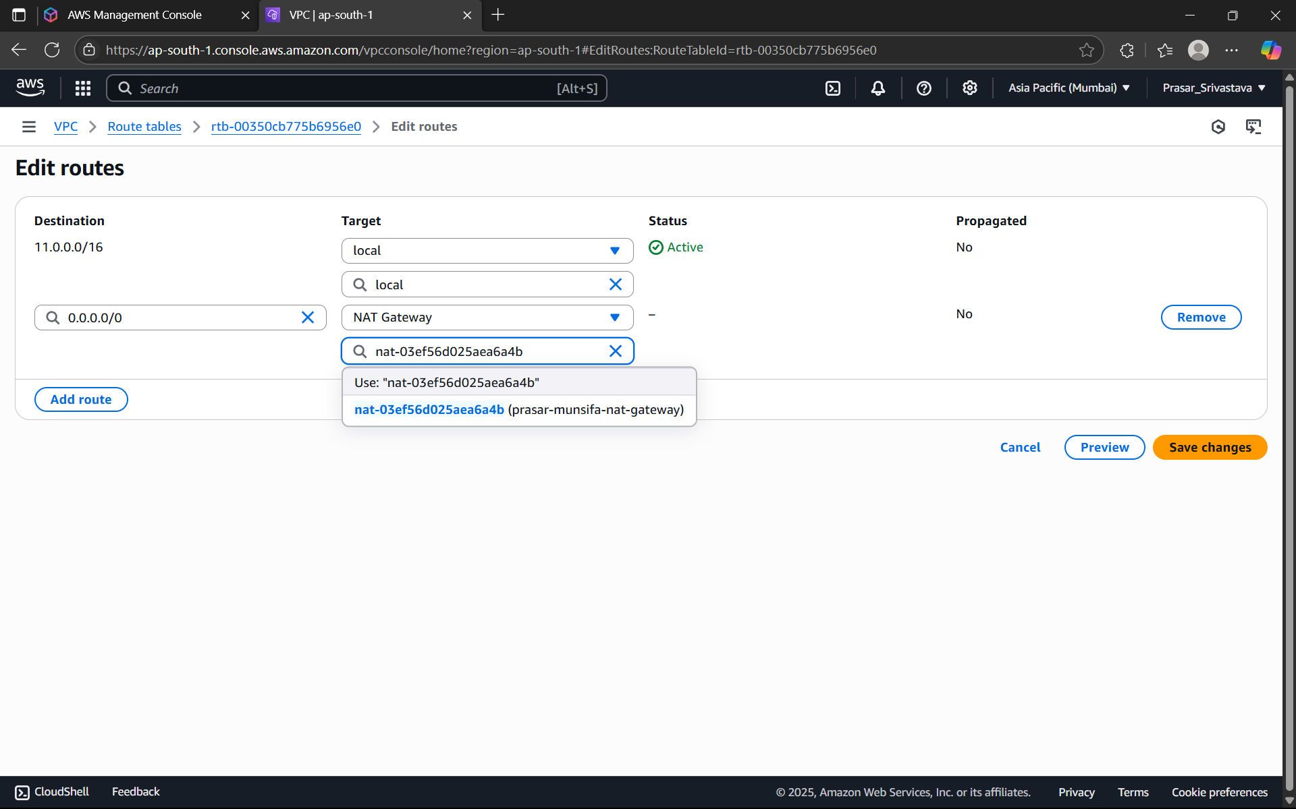

STEP30: PRIVATE SUBNET IS UPDATED WITH NAT GATEWAY

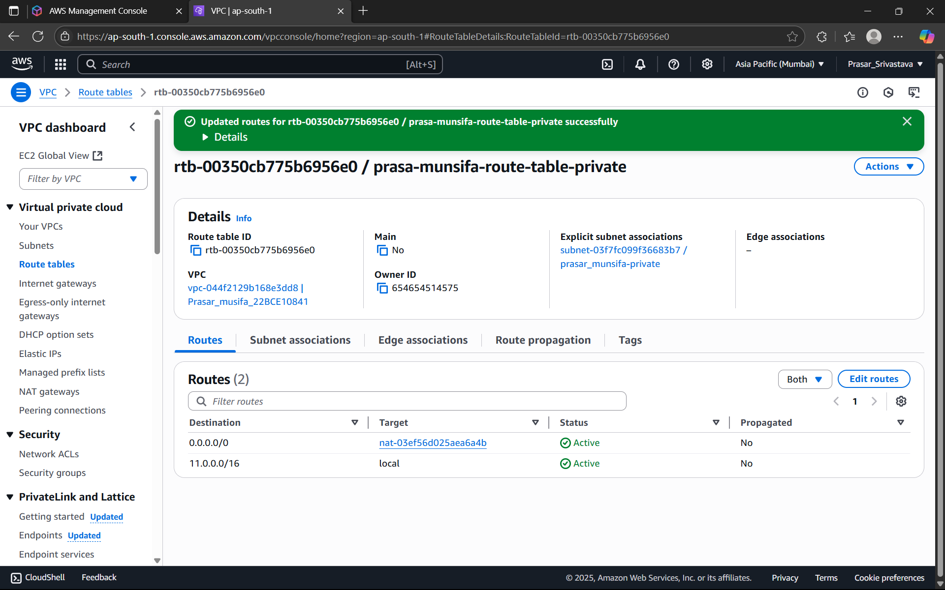

STEP31: WHOLE NETWORK SET UP IS READY, NOW WE HAVE TO CREATE EC2 INSTANCES

FOR BOTH PUBLIC AND PRIVATE SUBNET. SEARCH FOR EC2>CLICK ON EC2

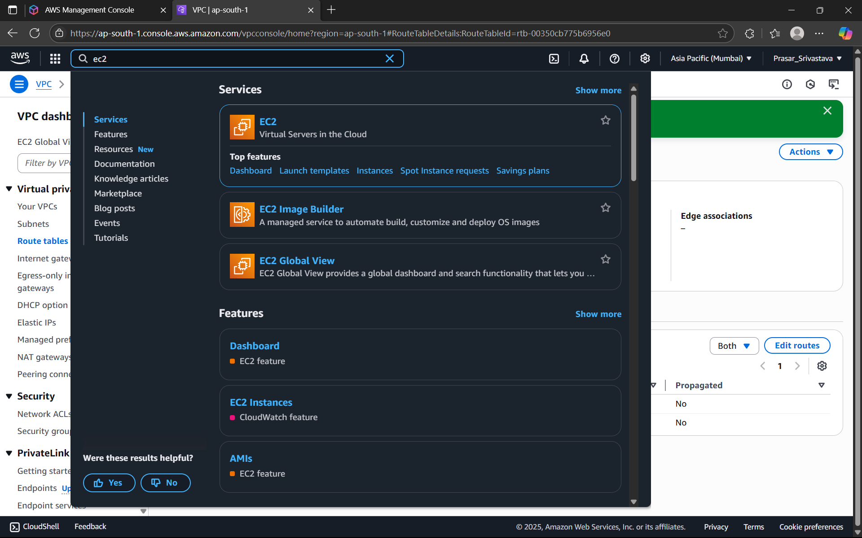

STEP 32: CLICK ON LAUNCH INSTANCE

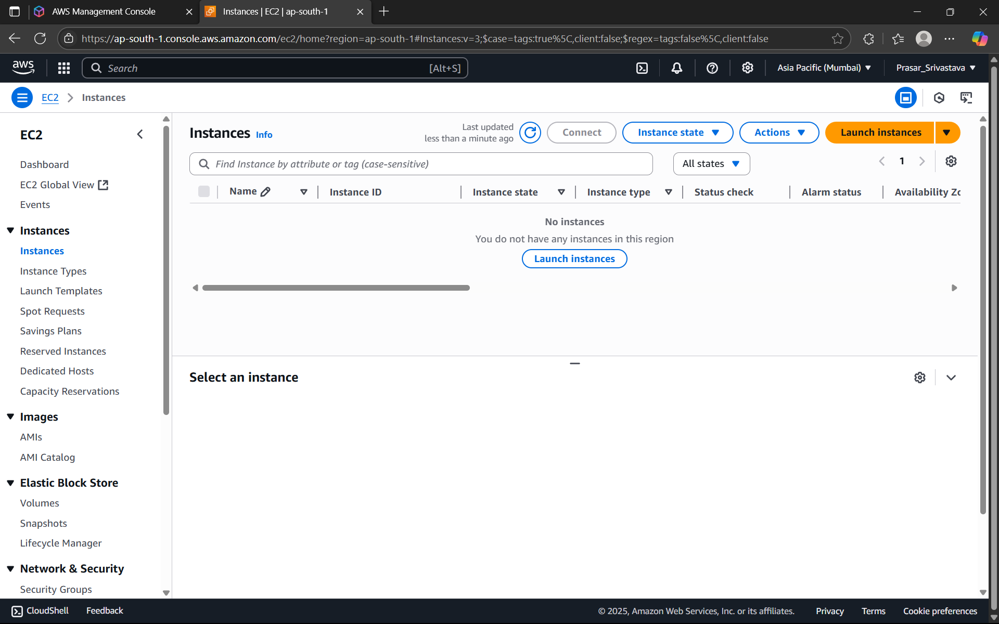

STEP 33: GIVE A SUITABLE INSTANCE NAME>CHOOSE OS:UBUNTU

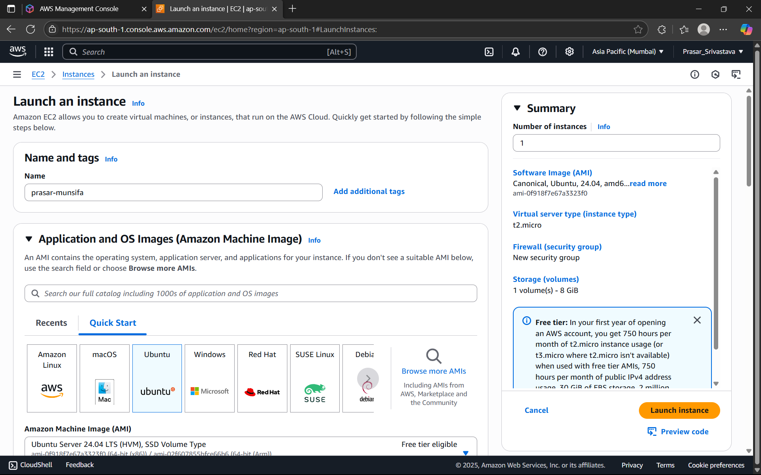

STEP 34: CHOOSE THE DEFAULT ARCHITECTURE> FREE TIER INSTANCE TYPE

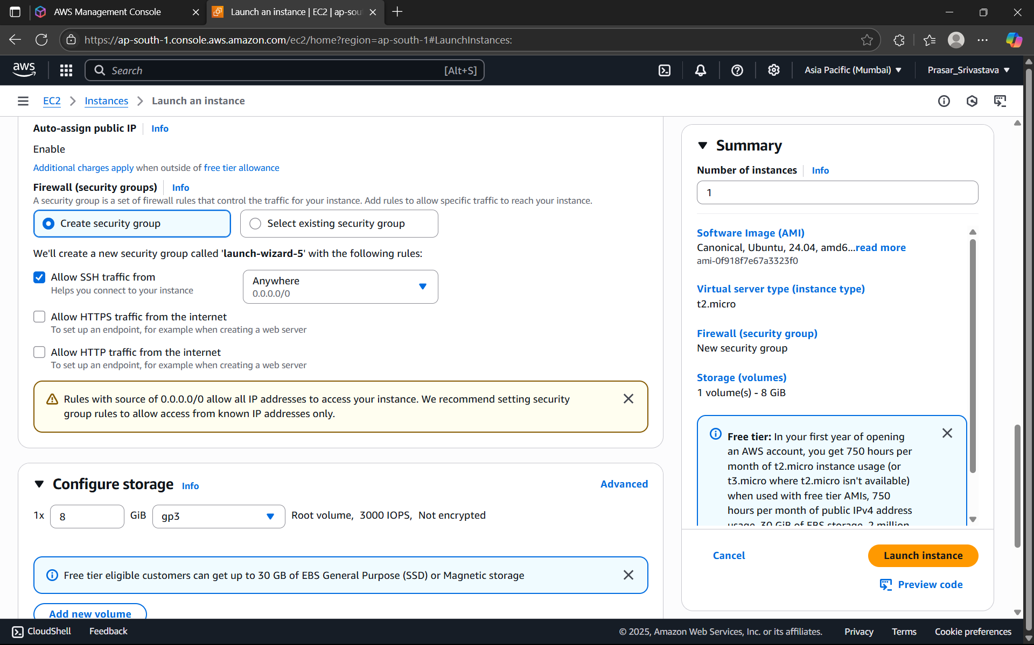

STEP 35: CREATE KEY PAIR

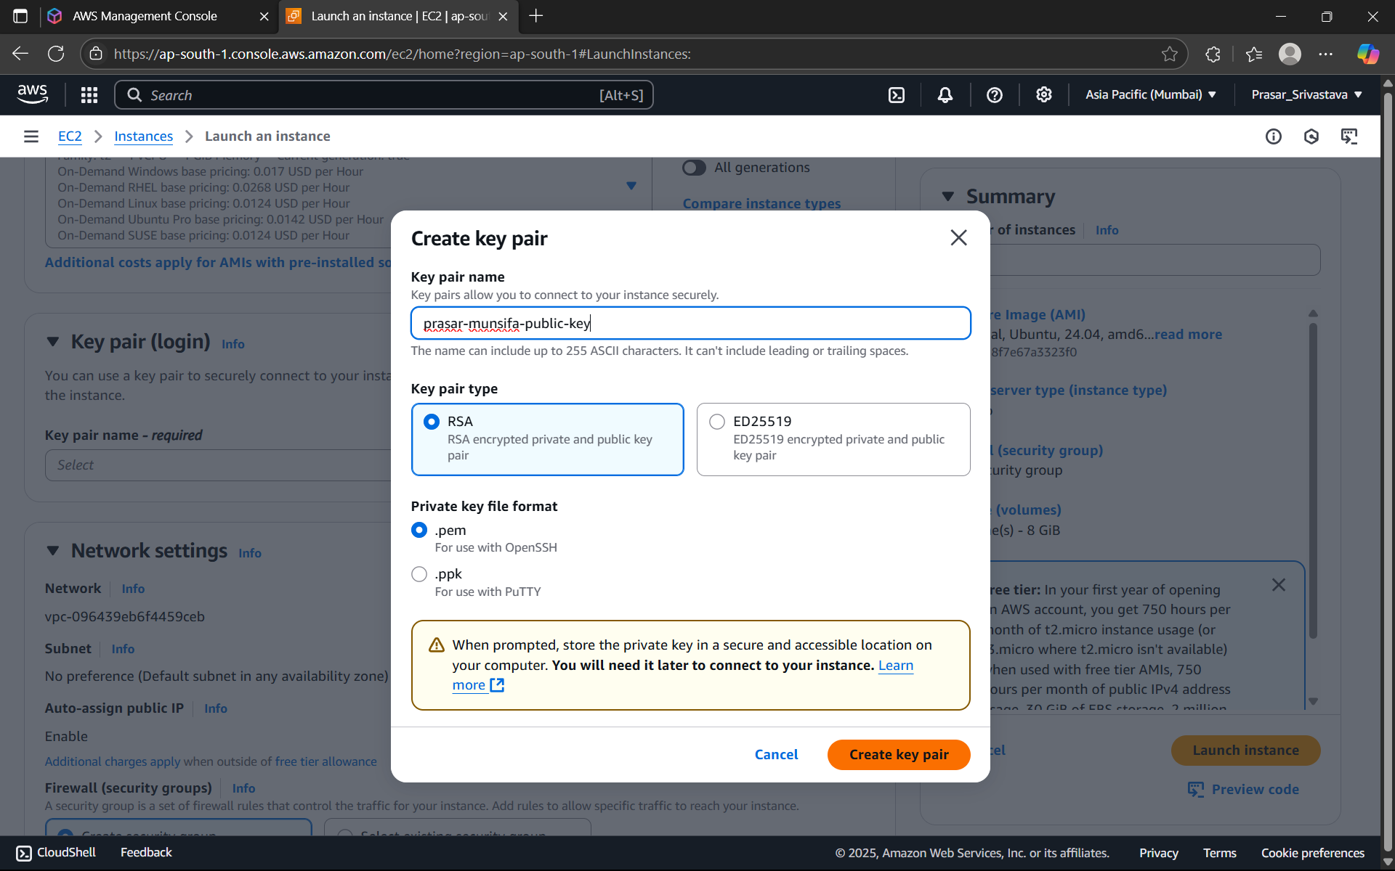

STEP 36: EDIT THE NETWORK SETTING>CHOOSE THE VPC CREATED EARLIER>SELECT THE

PUBLIC SUBNET> ENABLE THE AUTO-ASSIGN PUBLIC IP>CHOOSE CREATE SECURITY GROUP

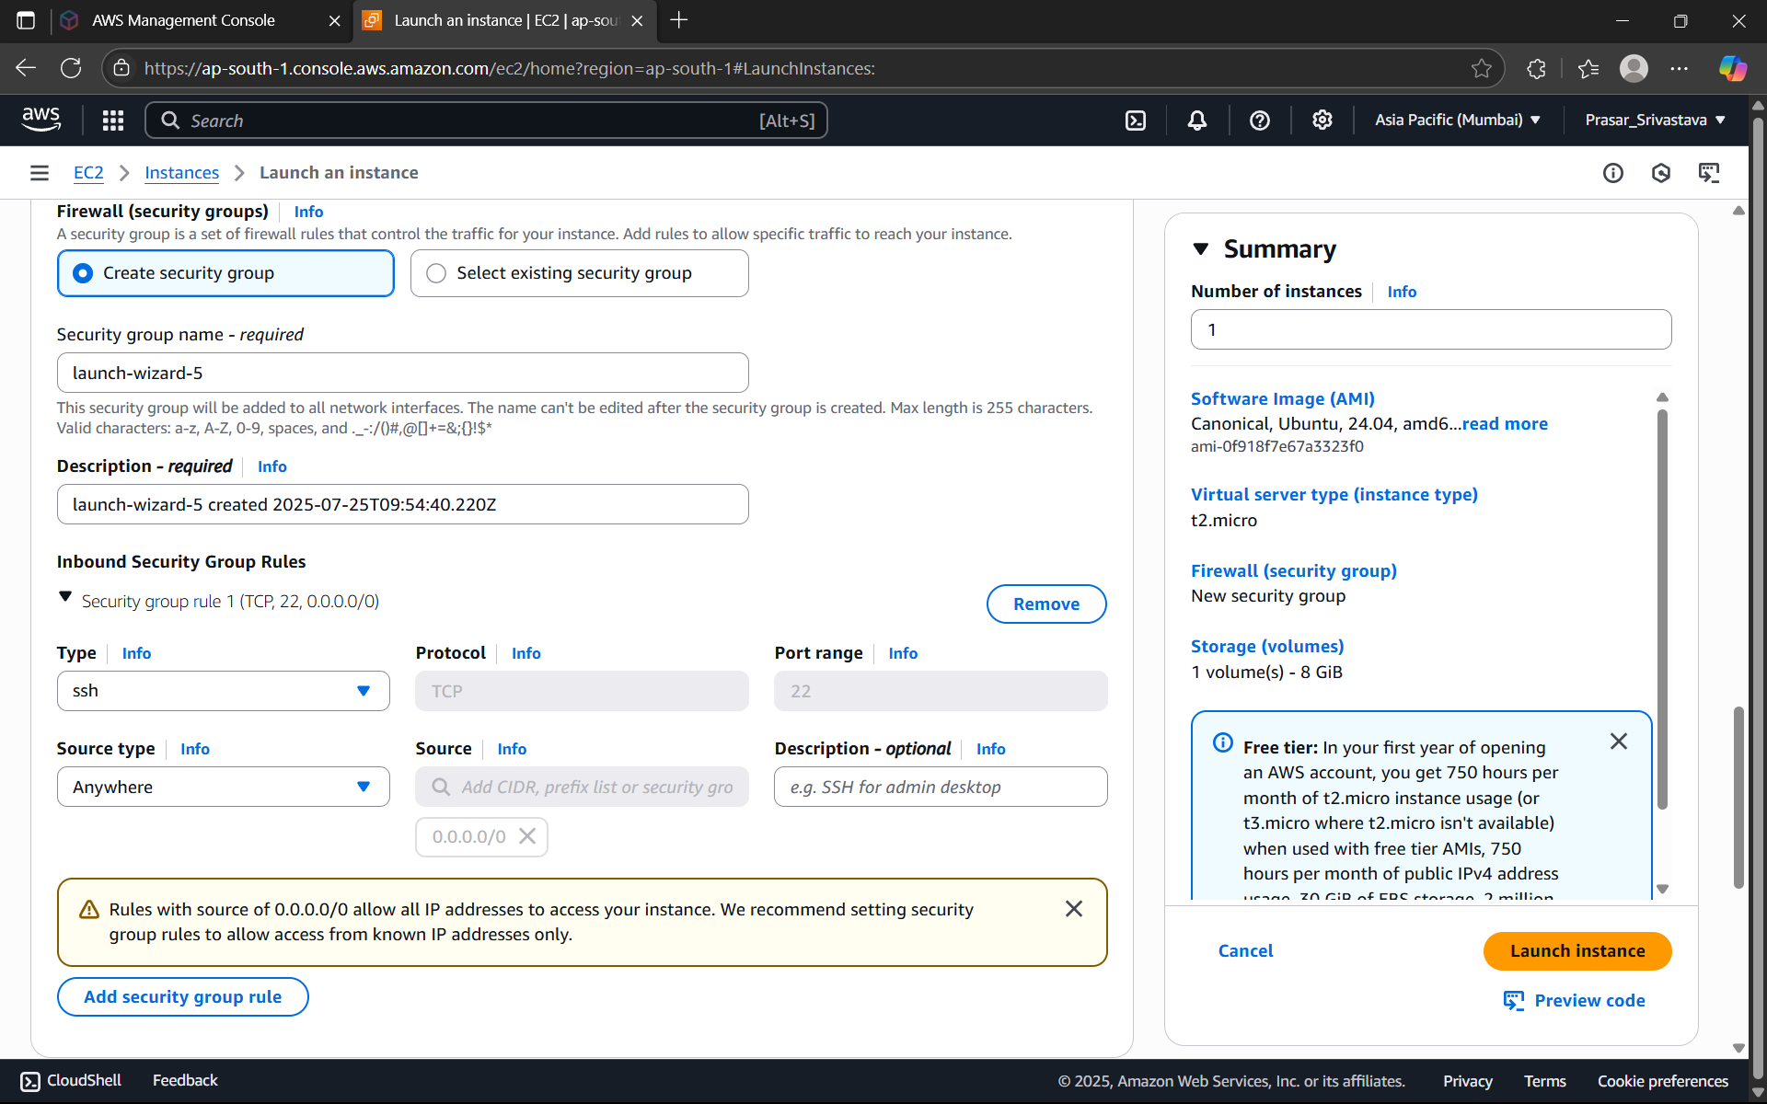

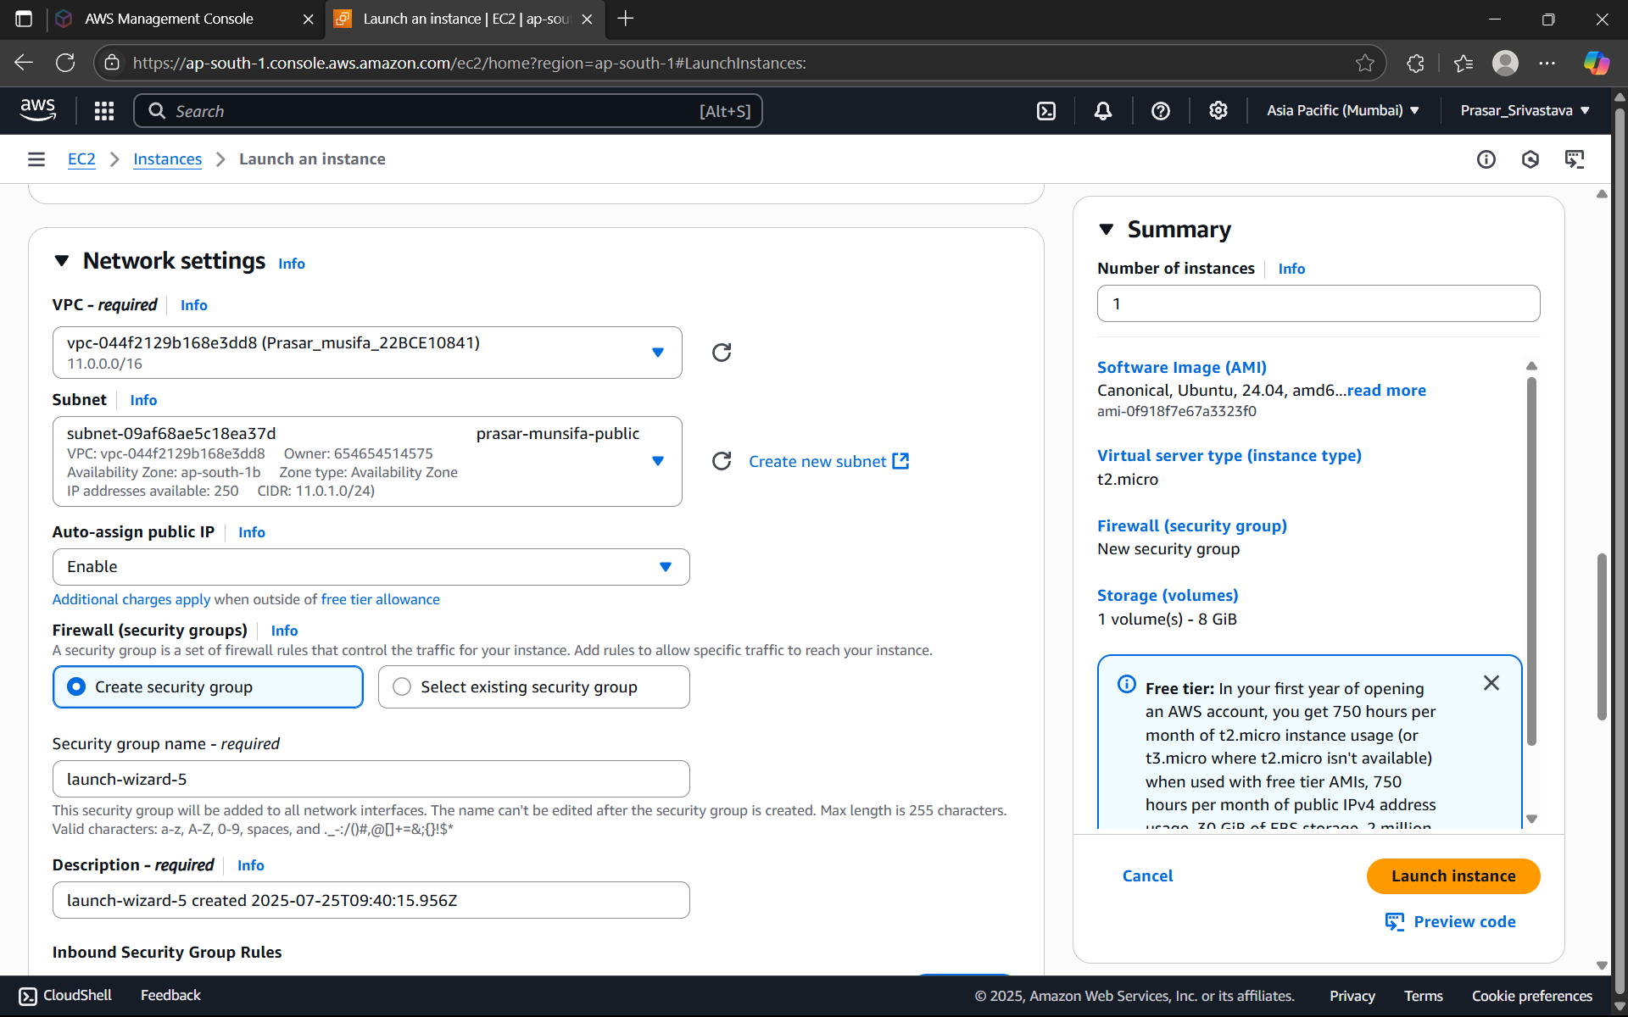

STEP 37: SECURITY GROUP RULE-1 IS DEFAULT> CLICK ON ADD SECURITY GROUP RULE



STEP 38: CHOOSE ALL ICMP-IPV4> SOURCE:0.0.0.0/0

STEP 39: CHOOSE DEFAULT CONFIGURE STORAGE: 8GB>CLICK ON LAUNCH INSTANCE

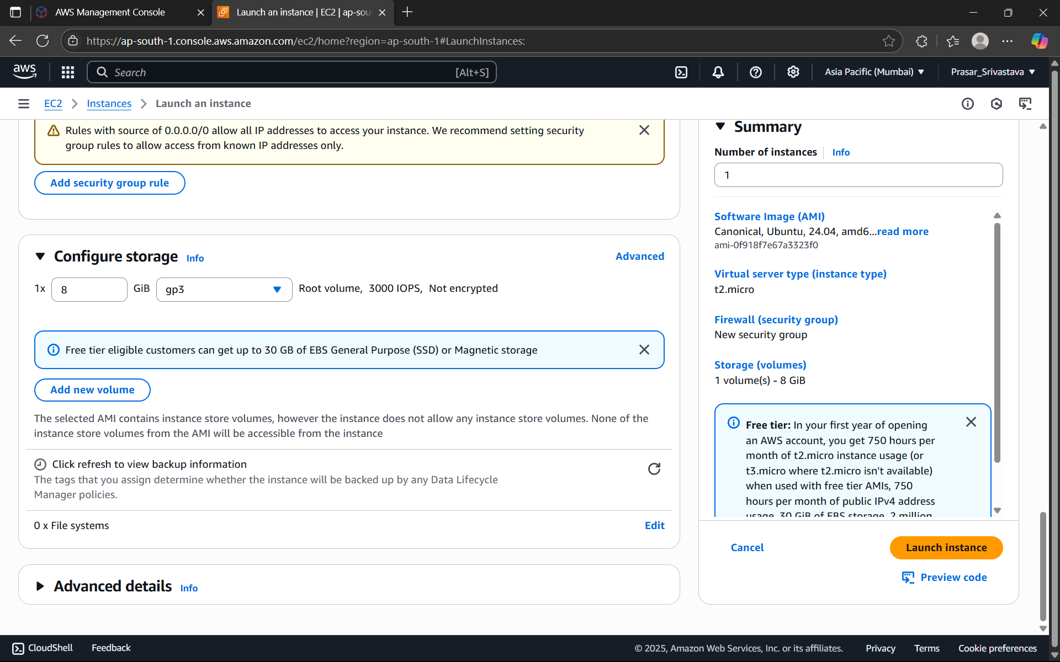

STEP 40: PUBLIC INSTANCE CREATED

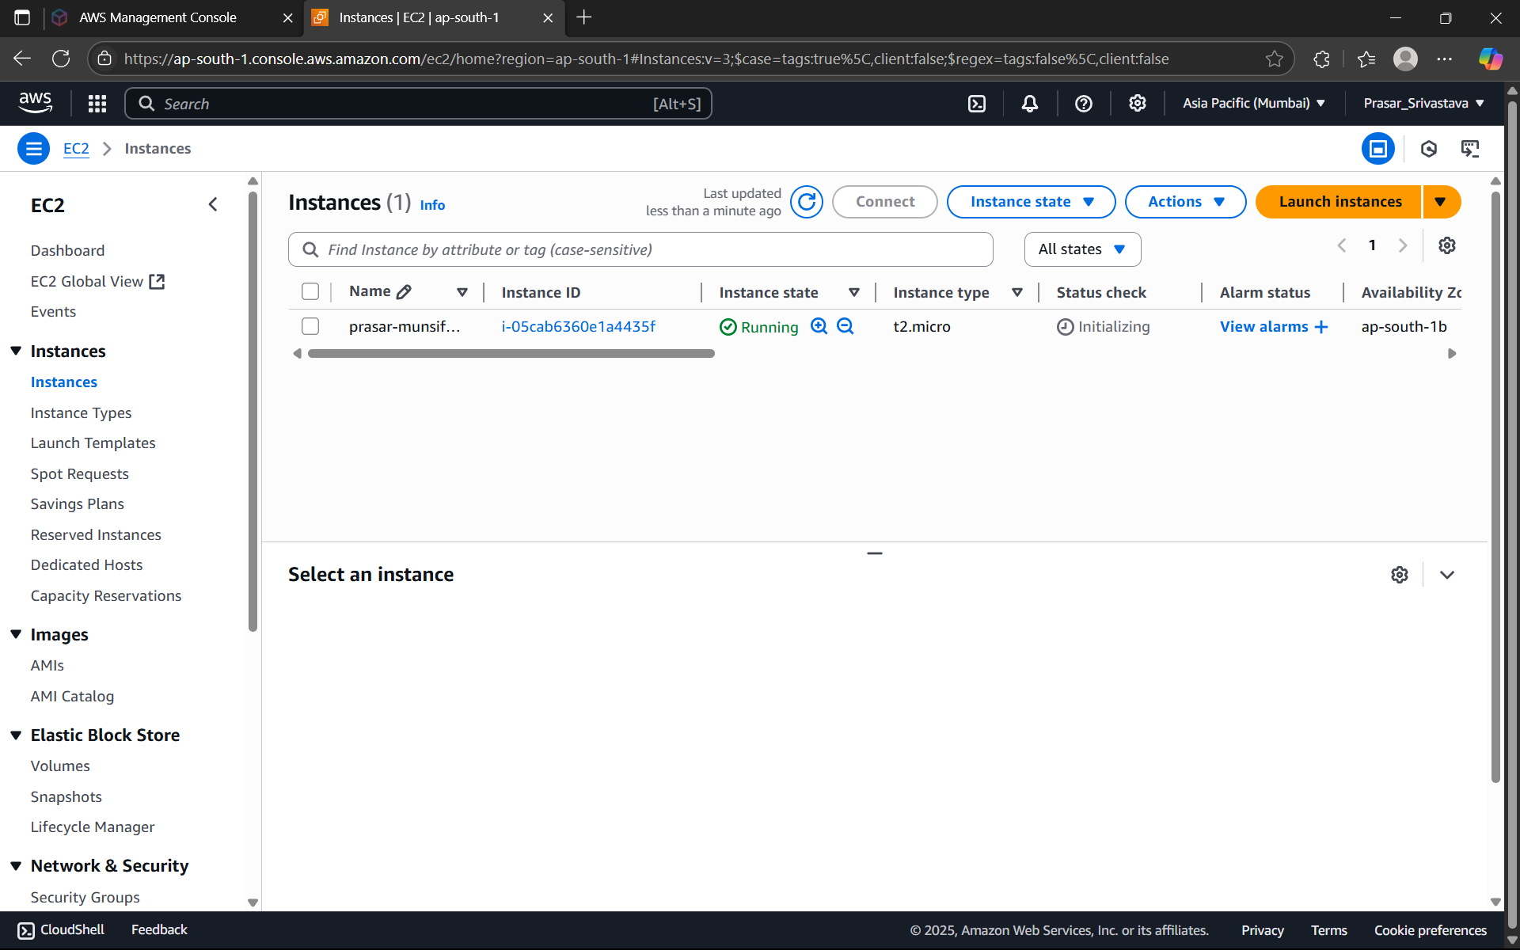

STEP 41: CREATE EC2 INSTANCE FOR PRIVATE SUBNET WITH THE SAME STEPS

DISABLE AUTO-ASSIGN-PUBLIC IP.

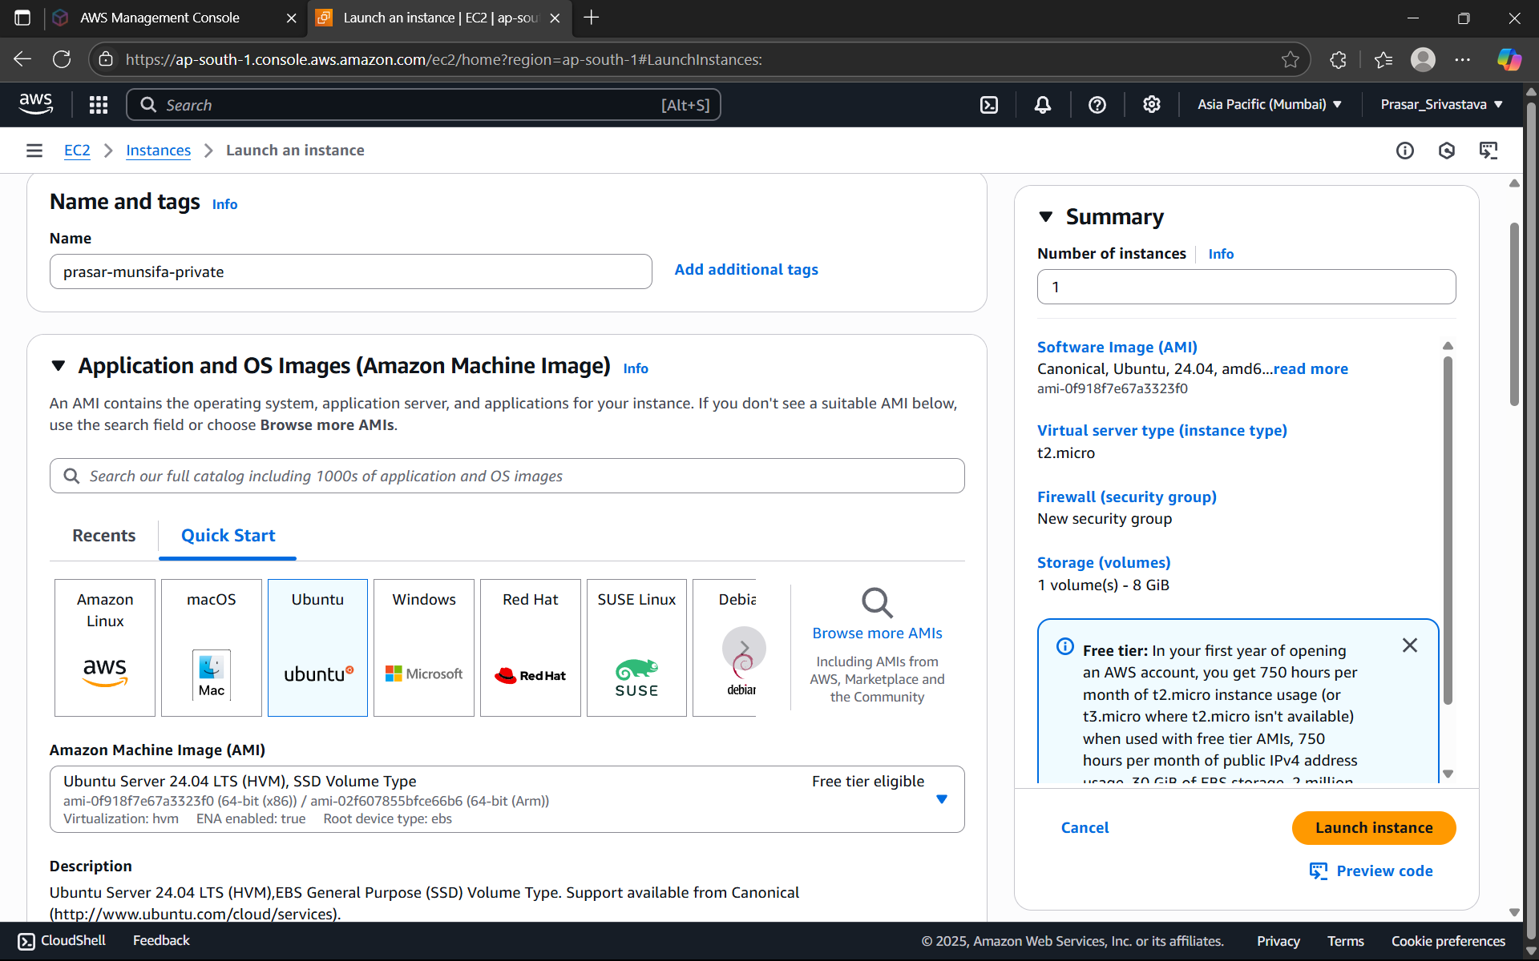

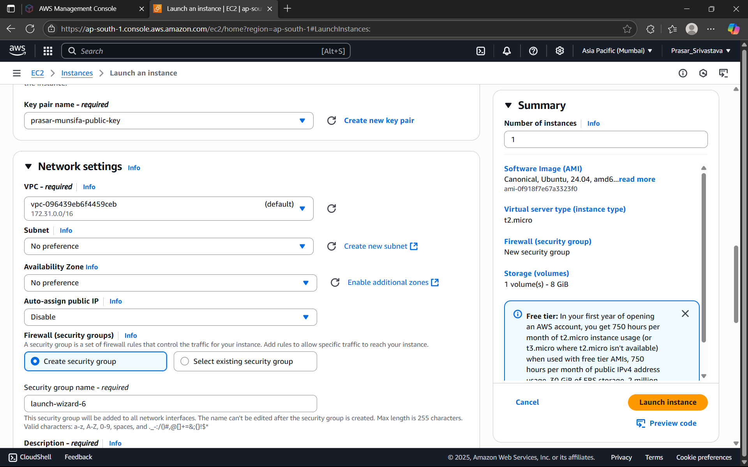

STEP 42: ADD SECURITY GROUP RULE>CHOOSE ALL ICMP-IPV4>

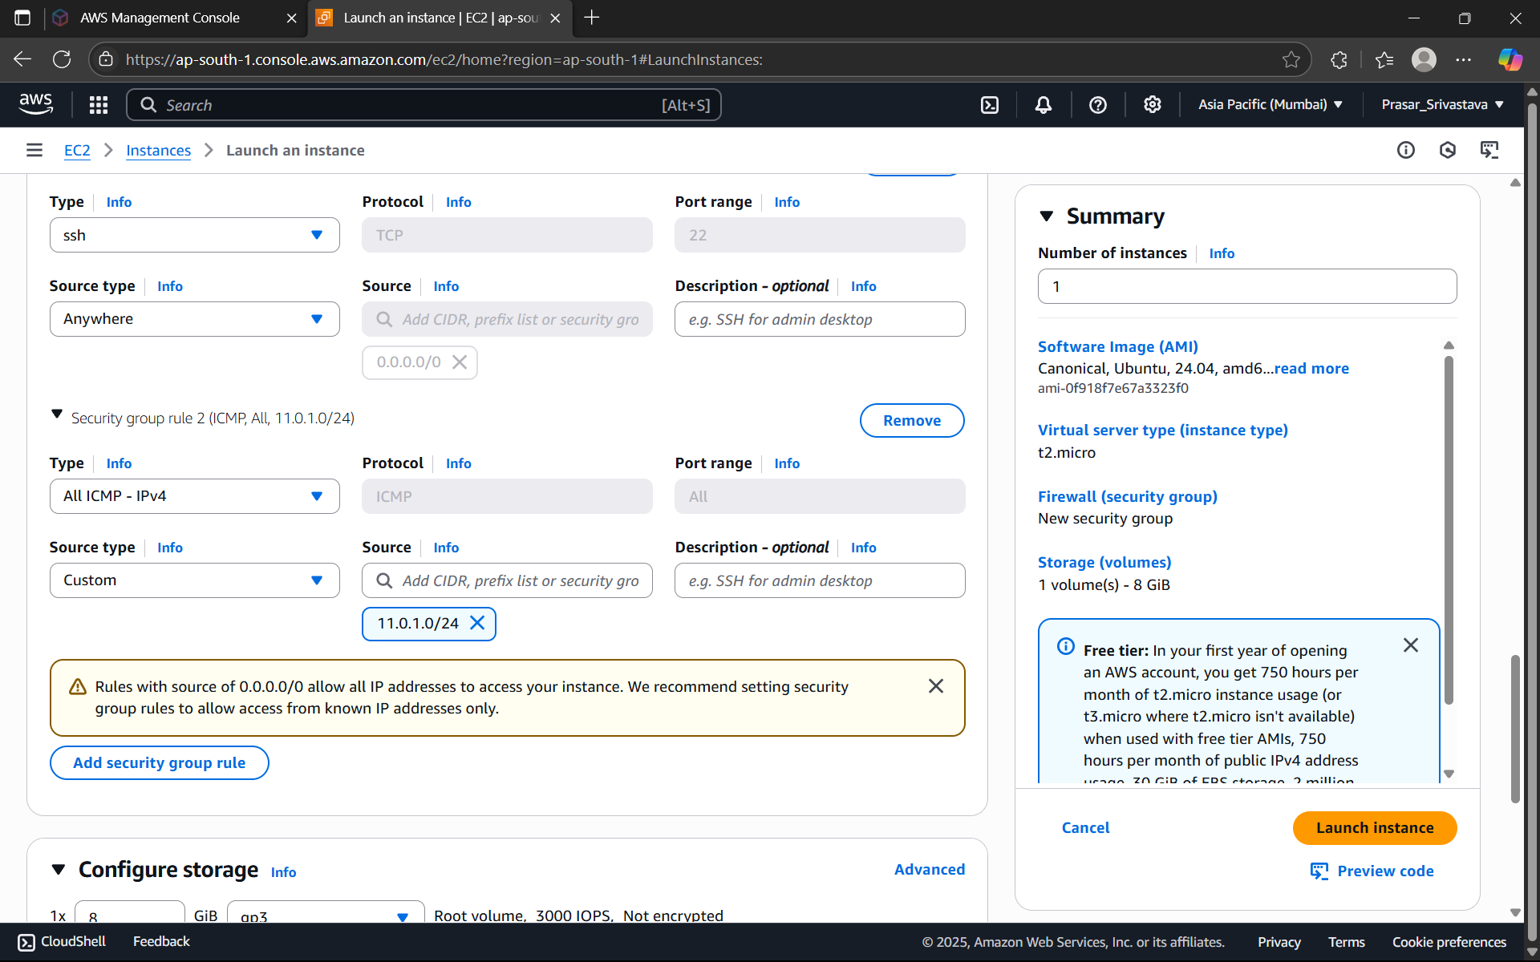

SOURCE:11.0.1.0/24(PUBLIC SUBNET IP ADDRESS, COZ ONLY PUBLIC SUBNET CAN ACCESS

THE PRIVATE SUBNET)>KEEP DEFAULT STORAGE>CLICK ON LAUNCH INSTANCE

STEP 43: PRIVATE EC2 INSTANCE IS CREATED

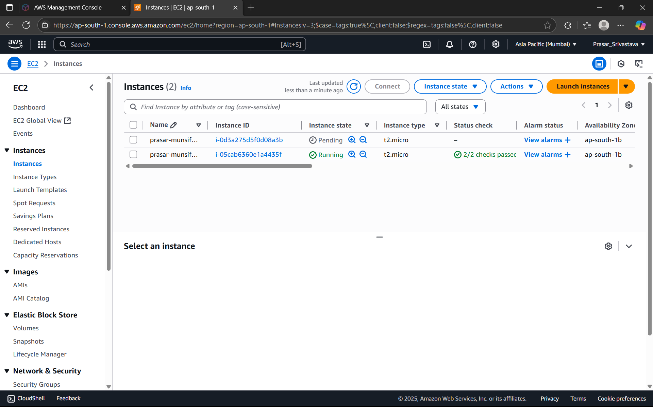

STEP 44: NOW CONNECT THE PUBLIC EC2 INSTANCE.CLICK ON THE PUBLIC INSTANCE>

CLICK ON CONNECT

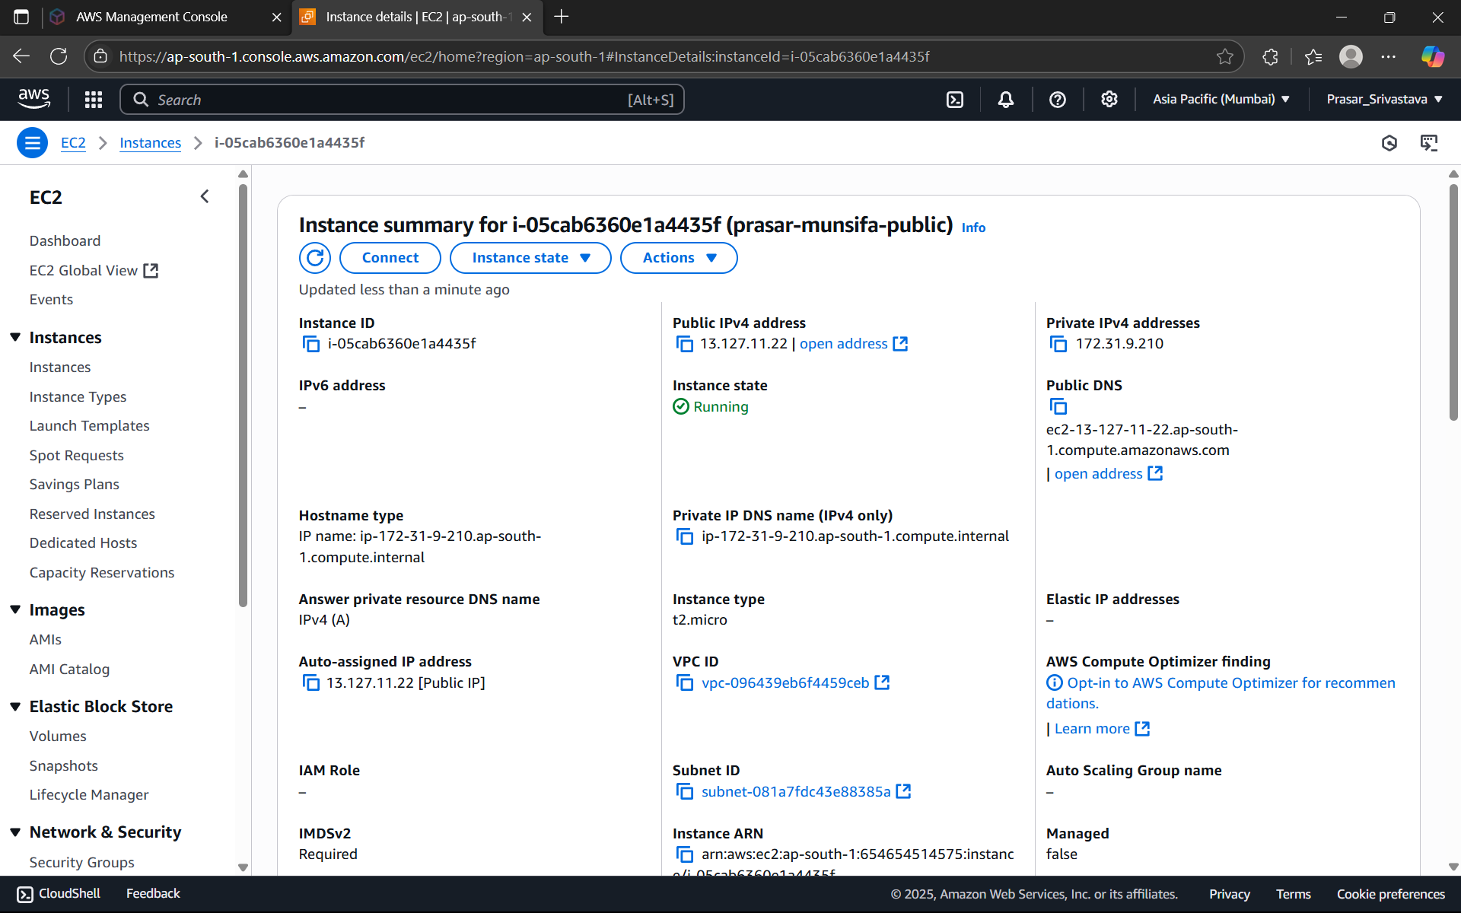

STEP 45: CLICK ON SSH CLIENT> COPY THE EXAMPLE AND PASTE IN TERMINAL TO

CONNECT

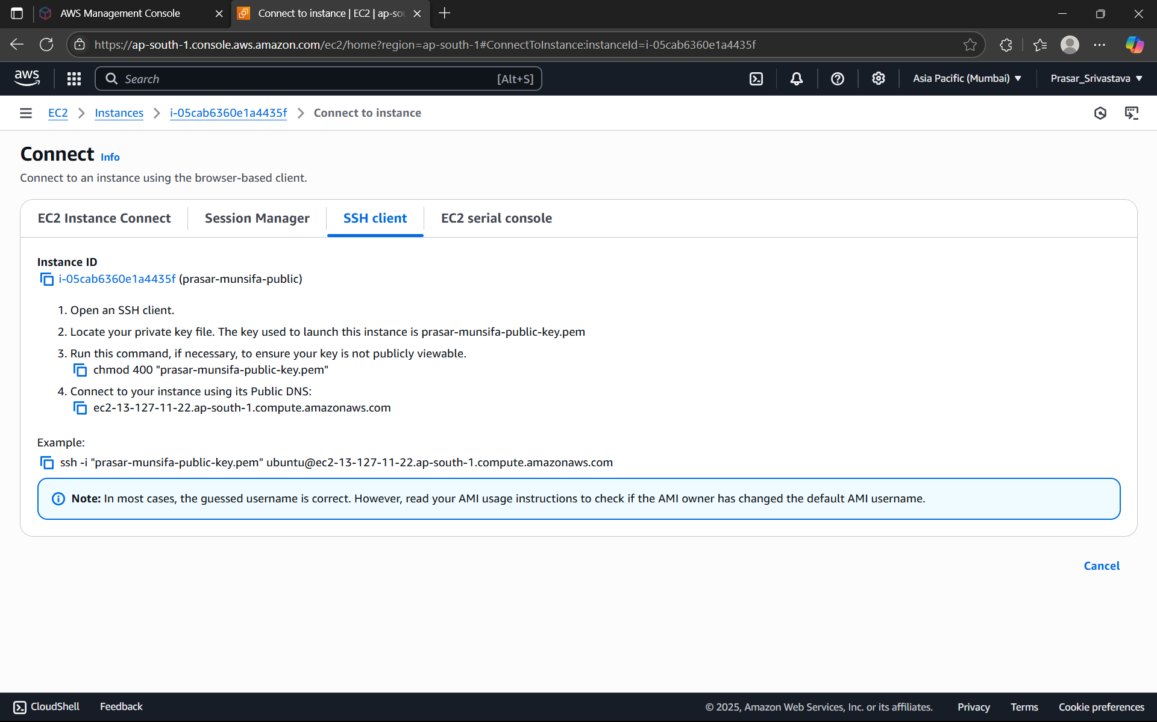

STEP 46: OPEN THE TERMINAL IN YOUR LAPTOP AND TYPE THE FOLLOWING COMMAND>

NOW PASTE THE COMMAND HERE FROM THE SSH CLIENT

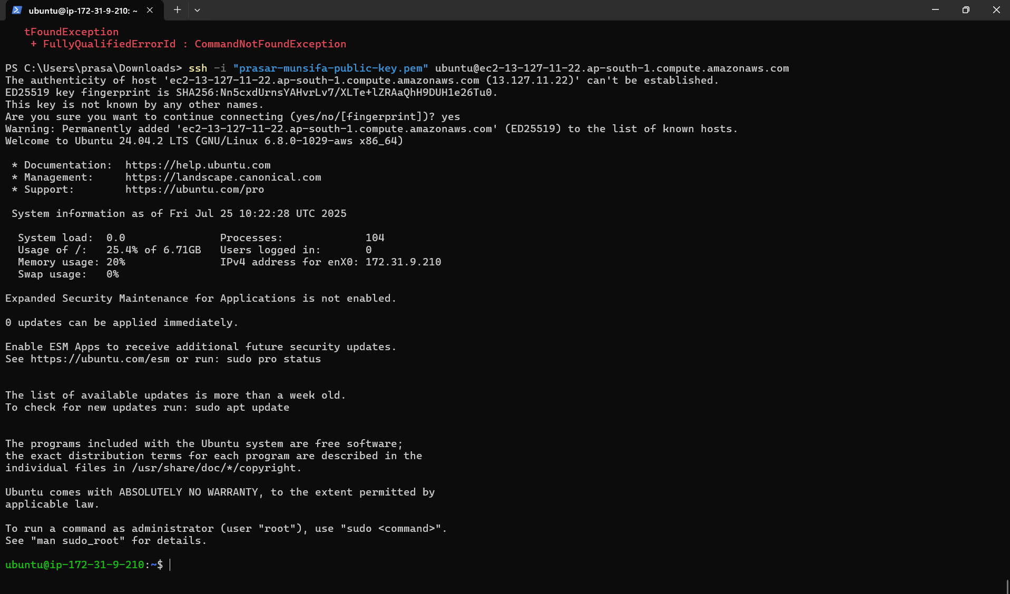

STEP 47: PUBLIC EC2 INSTANCE IS CONNECTED

STEP 48: NOW PING THE PUBLIC EC2 INSTANCE WITH THE HELP OF YOUR LOCAL

TERMINAL. GO TO INSTANCE AND COPY ITS IP ADDRESS AND TYPE THE FOLLOWING

COMMAND. (IT MEANS FROM OUTSIDE AWS, WE ARE ABLE TO CONNECT TO THE PUBLIC

EC2 INSTANCE)

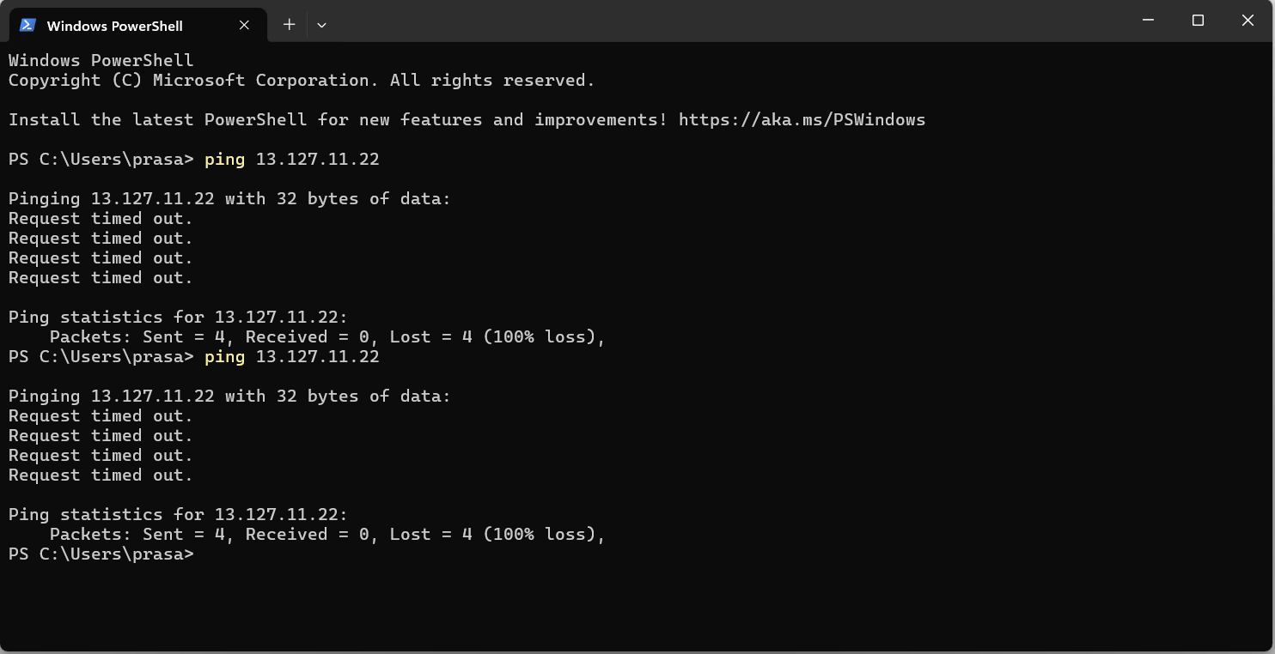

STEP 49: NOW NEXT FROM PUBLIC EC2 INSTANCE TERMINAL, TYPE THE FOLLOWING

COMMAND TO ACCESS RESOURCE FROM OUTSIDE THE AWS

NOTE: curl ipinfo.io: It is a command used in the terminal to retrieve information about your

current IP address using the "curl" tool and the "ipinfo.io" web service; essentially, it fetches

details like your location, ISP, and public IP address by sending a request to the IPinfo.io API

via the curl command.

It is seen that public EC2 instance is accessible from outside world as well as it can also

access outside resources. But we know that, private instance that we have created under

private subnet is not accessible from outside world but it can be accessed by the public EC2

instance only.

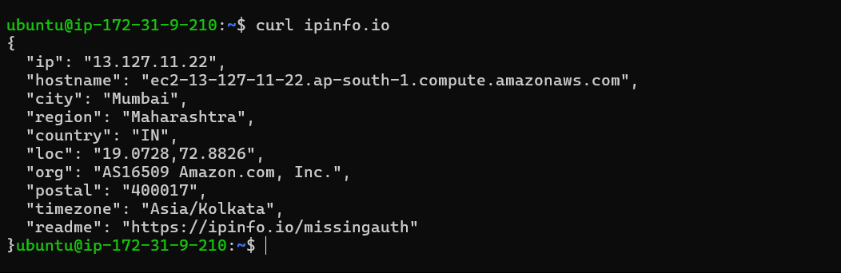

STEP 50: PING PRIVATE EC2 INSTANCE FROM THE LOCAL TERMINAL. COPY THE PRIVATE IP

ADDRESS OF THE INSTANCE AND TYPE (PING 11.0.2.160) IN THE LOCAL TERMINAL.

ITS SHOWING REQUEST TIMED OUT. i.e., IT IS UNABLE TO CONNECT TO THE PRIVATE EC2

INSTANCE FROM THE LOCAL TERMINAL. NOW LET’S TRY TO CONNECT IT FROM THE PUBLIC

EC2 INSTANCE TERMINAL.

STEP 50: TYPE THE FOLLOWING COMMAND TO CONNECT TO THE PRIVATE EC2 INSTANCE

(PING 11.0.2.160). CONNECTION ESTABLISHED AS SHOWN BELOW.

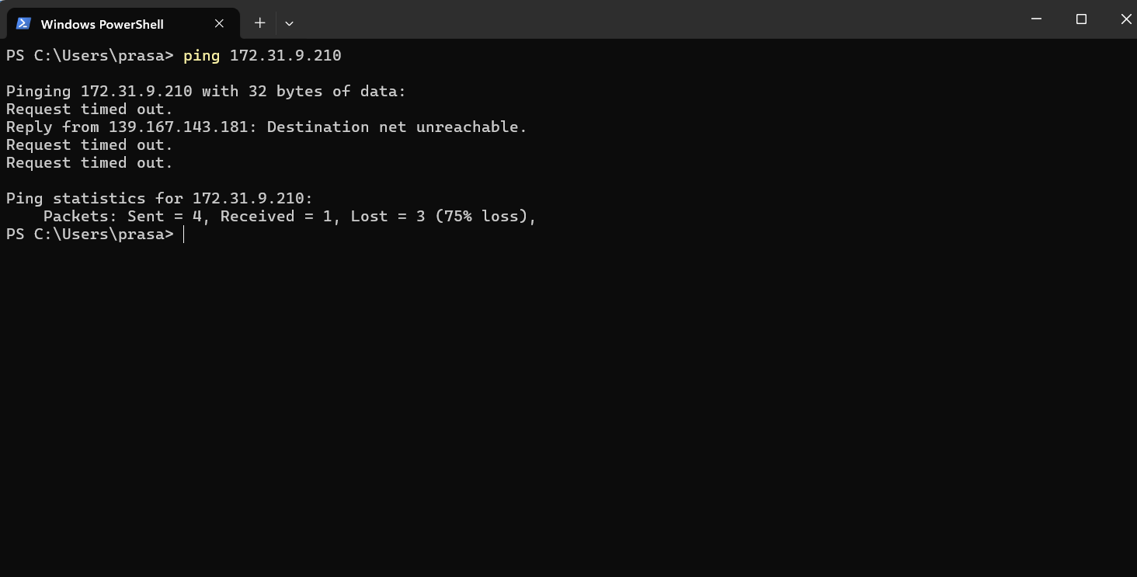

RELEASE ALL THE RESOURCES THAT ARE USED IN THE EXECUTION OF THE LAB.

1. TERMINATE THE EC2 INSTANCES.

2. DELETE ROUTE TABLE:

a. ROUTE TABLE>EDIT ROUTE>REMOVE NAT GATEWAY (PRIVATE)

b. ROUTE TABLE>EDIT ROUTE>REMOVE INTERNET GATEWAY (PUBLIC)

c. ROUTE

TABLE>SUBNET

ASSOCIATIONS>EDIT

ASSOCIATIONS>DESELECT>SAVE CHANGES

d. SELECT BOTH THE ROUTE TABLES>ACTIONS>DELETE ROUTE TABLES.

3. DELETE SUBNETS:

SUBNET

a. SUBNETS> SELECT BOTH THE SUBNET ACTIONS>ACTIONS> DELETE SUBNET

4. DELETE NAT GATEWAY:

a. NAT GATEWAY>SELECT THE NAT GATEWAY>ACTIONS> DELETE NAT GATEWAY

5. DELETE VPC

a. VPC>SELECT THE VPC CREATED>ACTIONS>DELETE

6. RELEASE ELASTIC IP

a. ELASTIC IP>SELECT THE ELASTIC IP>ACTIONS>RELEASE THE ELASTIC IP